Docker running notes

Source: Udemy course: Docker from Scratch [2023 - For Java Developers]

What is docker?

* An open-source platform for
  + Packaging the app + all needed dependencies + run time
  + Running the (dockerized) applications

Docker terminology:

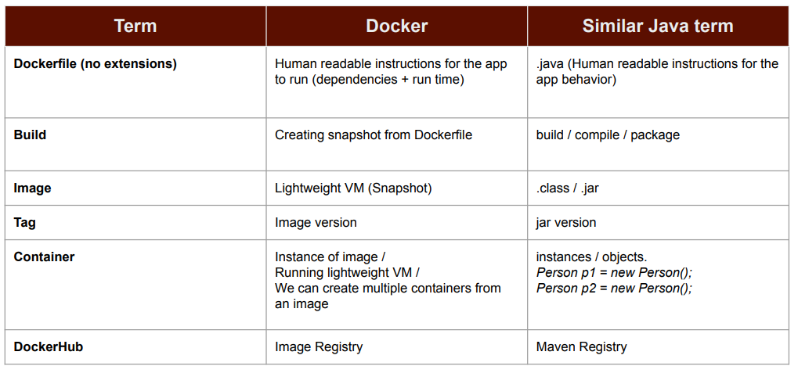

Docker commands:

|  |  |  |
| --- | --- | --- |
| Command | option | Purpose |
| docker system prune -af | f – stands for force fully delete  -af – tells delete everything **except images** | To clean the existing container, images and temporary files from system |
| docker system prune -f | f – stands for force fully delete |
| docker image |  | To show the list of images you have in your machine |
| docker pull {image-name} |  | To pull the image from dockerhub |
| docker run {image-name} |  | Pull the image from dockerhub IF and only IF provided image is not present on the local machine and run the image. IF image is found on local then it will not try to pull the image. NOTE that always use docker pull command to get latest image changes because command docker run {image-name} just help to pull image first time not every time.  **docker run - create a container of the image.**  **Something like Person p1=new Person() in java** |
| docker run {image-name} | -it  -i -> std-input  -t -> std-output/ attach terminal | To start container in interactive mode |
| docker run {image-name} -name={container-name} |  | **-name** option used to assign the name to the container. |
| docker ps |  | List the current running container |
| docker ps | -a | List the current running container with all information like when it was start and when it was stop etc. |
| docker start {container_id/container_name} |  | Start the **existing** container which was stop. |
| docker start {container_id/container_name} | -ia | Start the **existing** container which was stop in interactive mode.  Ex: docker start -ia ubuntu |
| docker stop {container_id/container_name} |  | Gracefully stop the container, after running docker stop command the system will take 10 sec to stop the container |
| docker kill {container_id/container_name} |  | Immediately stop the container will not take 10 sec to stop the container. |
| docker exec {container_name/ID} {command} |  | Used to execute command on running container.  For example:  docker exec ubuntu_cn01 ls  Above command execute the ls command on existing running ubuntu_cn01 container. |
| docker run -p {system/host_port_no}:{container_port_no} {image_name} |  | To map the host/system port number to a container port. |
| docker run -p {system/host_port_no}_1:{container_port_no}_1  {system/host_port_no}_2:{container_port_no}_2 {image_name} |  | To map multiple ports for a container.  Or instantiating multiple instance of container on different-different ports. |
| docker run -d {image_name}  Ex:  docker run -d -p 7070:80 nginx |  | Run the container in detached mode. It means container will run in background and you can use the current prompt screen. |
| docker logs {container_id/name} |  | Print the logs of stopped or running container |
| docker run -v {system_path}:{container-path} {image_name}  Ex:  docker run -p 7070:80 --name c1 -v D:/ProjectsAndWorkspace/docker_playground:/usr/share/nginx/html:ro nginx |  | Map system/host directory to container directory |
| docker run -v  {system_path_1}:{container-path_1}  {system_path_2}:{container-path_2}  {image_name} |  | Map multiple system/host directories to container directories |
| docker rm {container_name/ID} |  | Remove given container |
| docker inspect {container_name} |  | Display all information of container |
| docker network create {network _name} |  | Create docker network |
| docker network ls |  | List docker network |
| docker network disconnect {network_name} {container_name} |  | Disconnect container from network |
| docker network connect {network_name} {container_name} |  | Connect container to network |
| docker network prune |  | Remove all unused networks |
| docker network rm {network_name} |  | Remove one or more networks |
| docker build {tag i.e -t} {image_name} {path_of_Dockerfile}  Ex: docker build -t my-hello-world . |  | Build the docker image from Dockerfile |
| docker-compose up  OR >> will be used when your file name is not docker-compose.yaml docker-compose -f {file_path}/{file_name.yaml} up |  | Used to execute docker-compose.yaml file. With this command as docker will pull images if required , do the configuration is provided and up the container. |
| docker-compose up -d |  | Detached mode |
|  |  |  |
| docker-compose down |  | Remove the container and networks that got created by docker-compose up command |
| docker-compose ps |  | List the containers |
| docker-compose logs {service-name} |  | List the logs |
| docker-compose –profile={profile_name} up | --profile | It tells that particular service will run if we run the docker-compose with particular profile name |
| for /F %i in ('docker images -a -q') do docker rmi -f %i |  | Remove all docker images on windows command prompt |

Mapping the port:

Problem:

Steps

1. Pull the nginx image (nginx is a server, you can pull any image like tomcat etc)
   1. docker pull nginx
2. list the images
   1. docker images

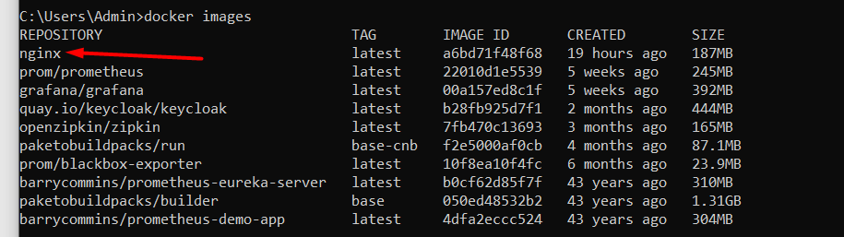

1. create container to run image

docker run nginx

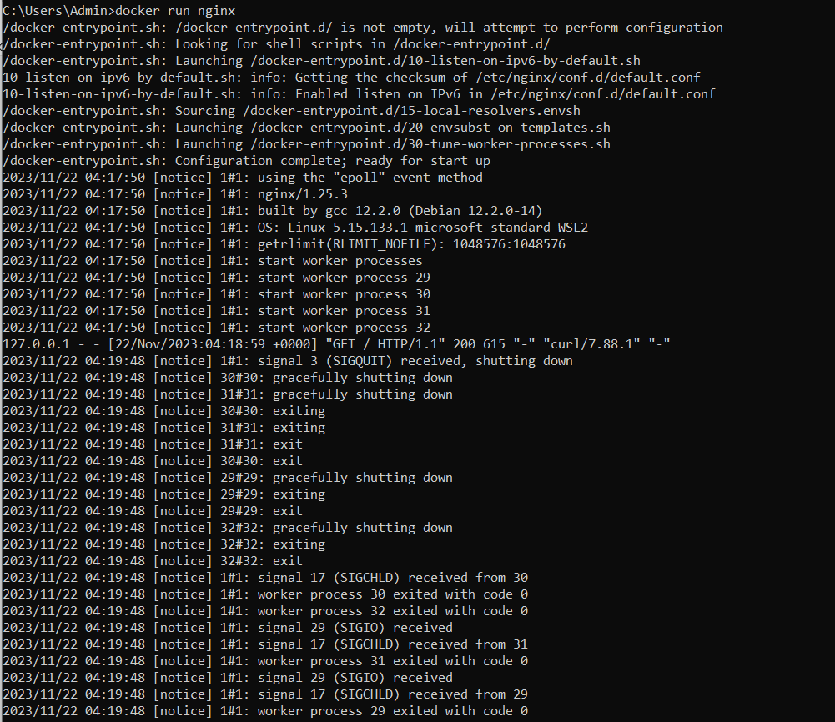Now the nginx server is started in docker container.

1. If you open browser and try below url then it won’t invoke nginx server home page.

<http://localhost>

1. The reason is nginx is running inside docker container and that also on some port number.
2. We can use docker exec command to interact the nginx server.
3. Command: docker exec -it { nginx_container_image_name} bash >> need to provide bash to tell docker we need some command prompt for interaction.

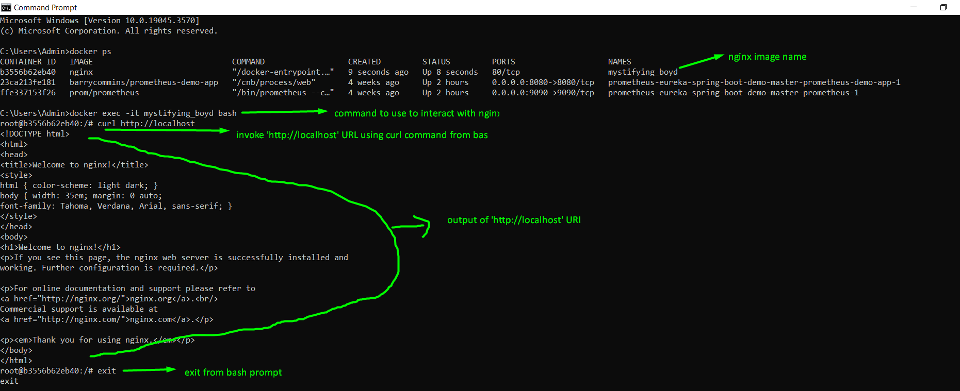

1. So what we have to do to access above <http://localhost> url from our system browser?
2. Run the container with port mapping like below

**docker run -p 80:80 nginx**

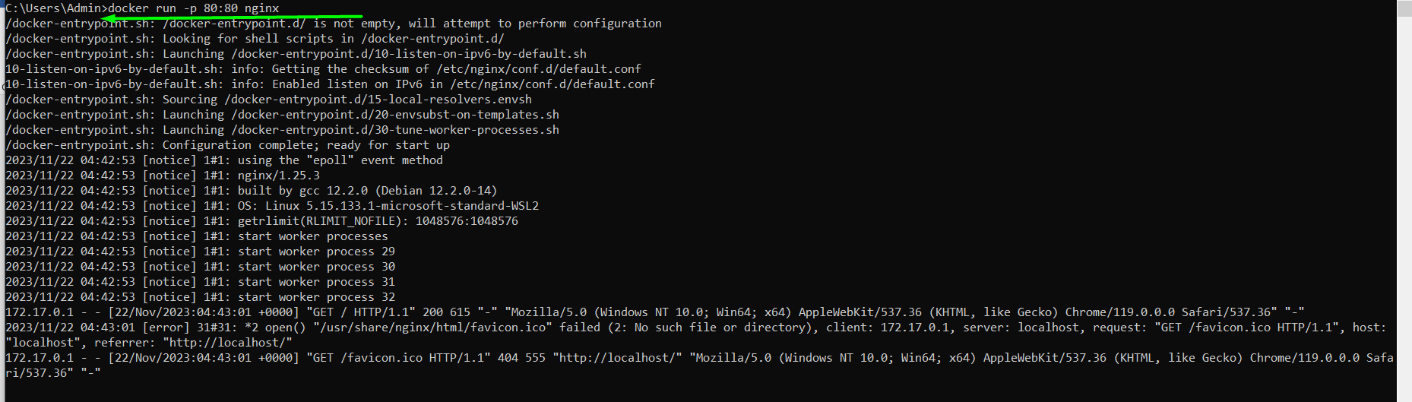

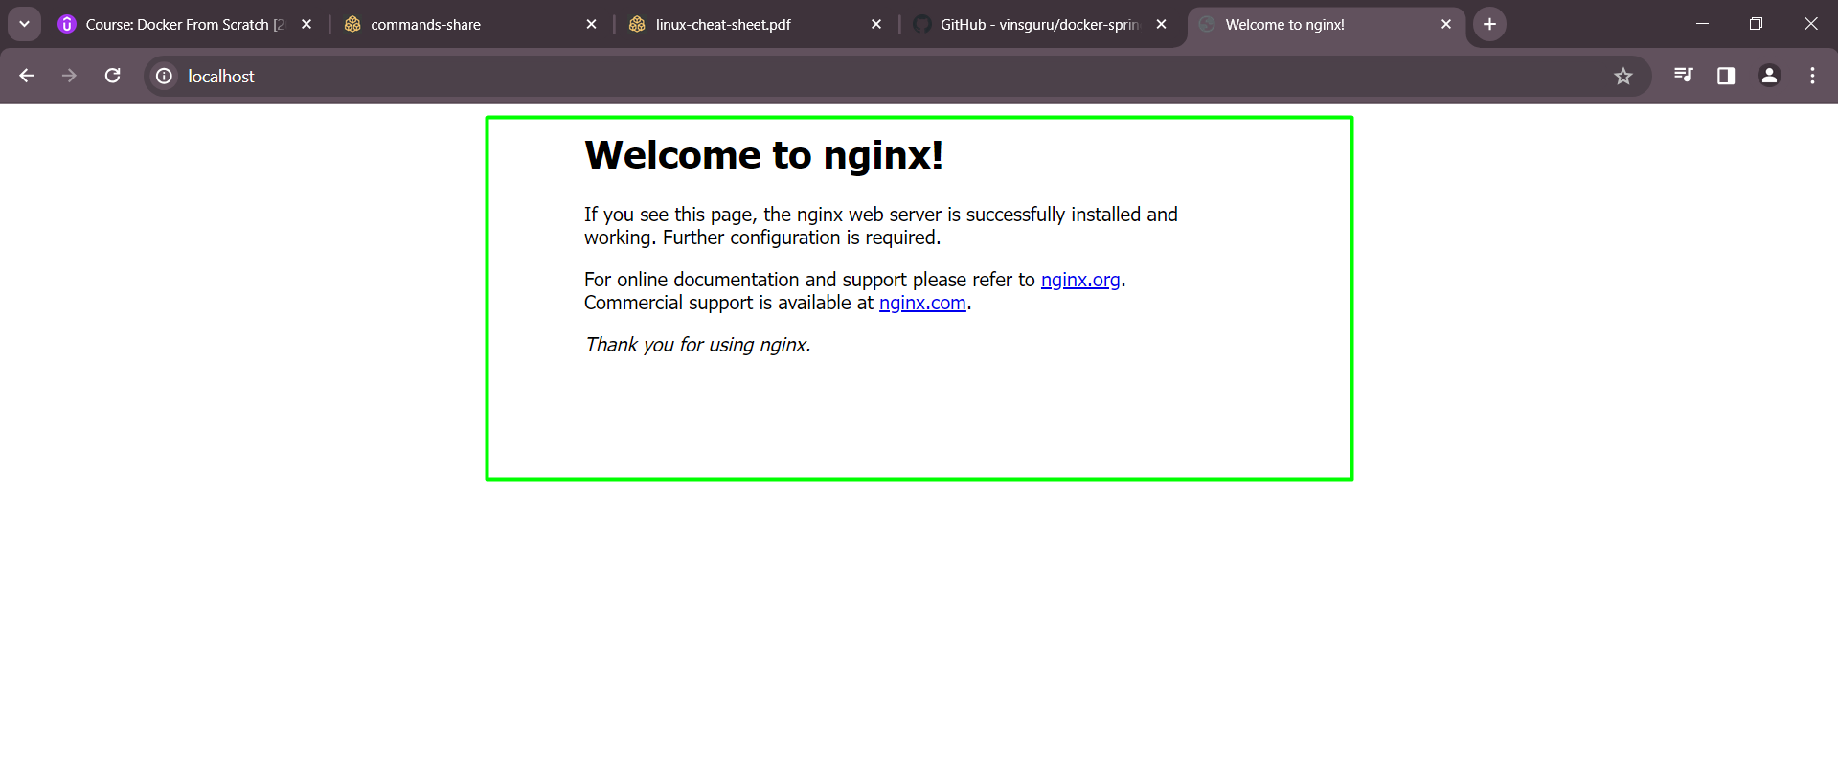

# Detach mode:

Below command use to run the nginx server container in non-detach mode, as you an see the logs of nginx server on console.

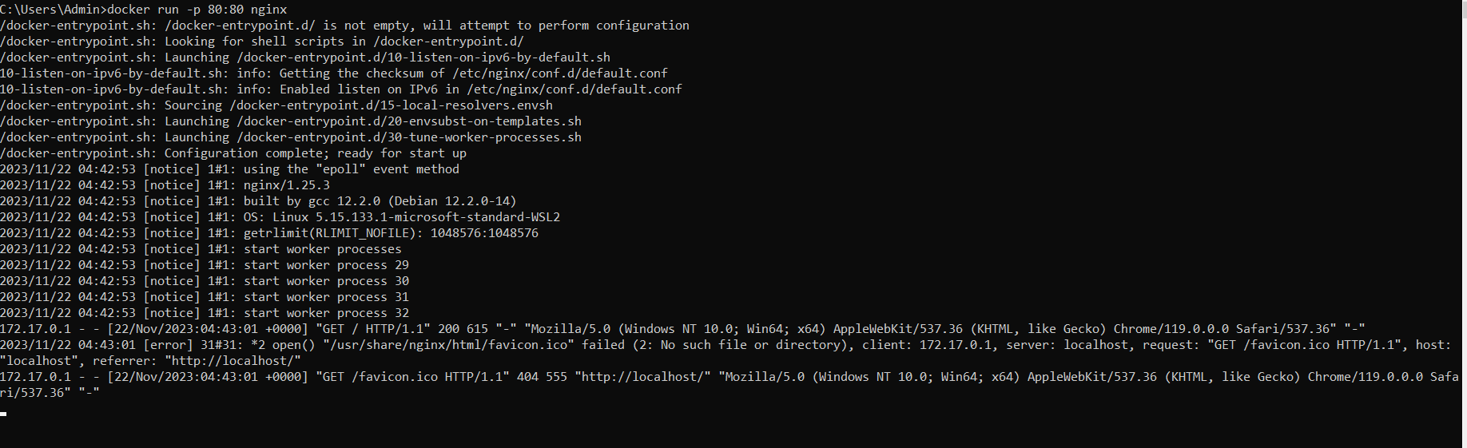

What if someone want to run the server in background and use same console for interaction.

Use docker run -d -p 7070:80 nginx to achieve same.

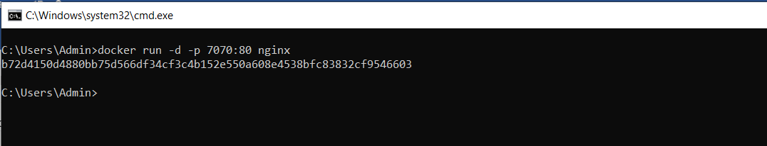

Check container is running or not:

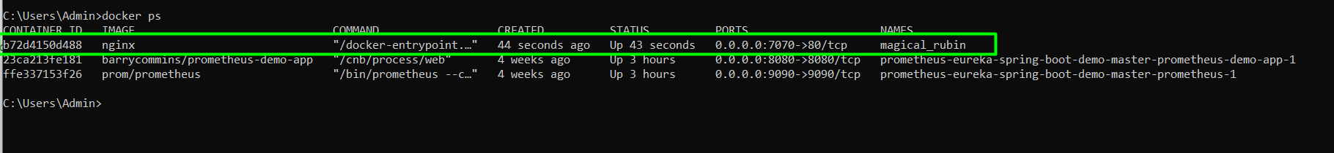

Accessing container logs:

docker logs {container_id}/name

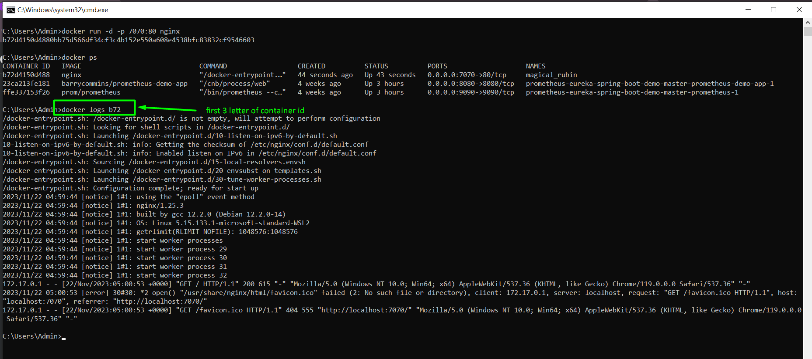

# Docker volume mapping:

As we know container are stateless, it means let say you have one problem/algorithm running on container and generating some valuable output as per nature of container the algorithm generated output will be vanished after container stop. So how do we store the result for long term.

Here is volume mapping option comes into picture. Volume mapping provide us **docker run** option to map the host/system directory to container.

Command:

docker run -v {system_path}:{container-path} {image_name}

Ex: docker run -v D:/ProjectsAndWorkspace/Demo:/sample/demo {image_name}

NOTE: if /sample/demo directory is not present then it will be created.

Example-2: mapping the nginx existing directory to system directory

docker run -p 7070:80 --name c1 -v D:/ProjectsAndWorkspace/docker_playground:/usr/share/nginx/html**:ro** nginx

here I have created index.html at D:/ProjectsAndWorkspace/docker_playground location so when I invoke <http://localhost:7070> from browser my custom index.html page get rendered not nginx default page.

**:ro – it tell read only mode. It means no one can delete/edit from docker**

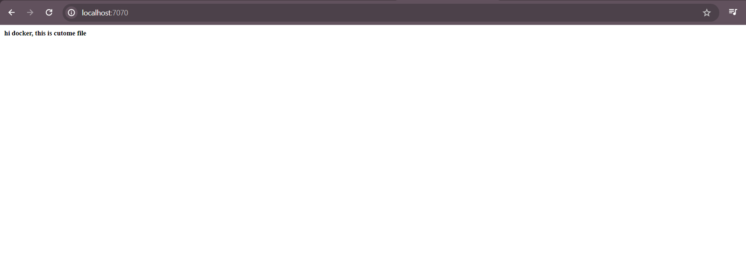

The original page look like this



And it is rendered from /usr/share/nginx/html

# Docker network:

Let say you have two docker container running and want to communicate with each other then follow below steps:

* Run nginx container (taking nginx for ref there may be a different container as well

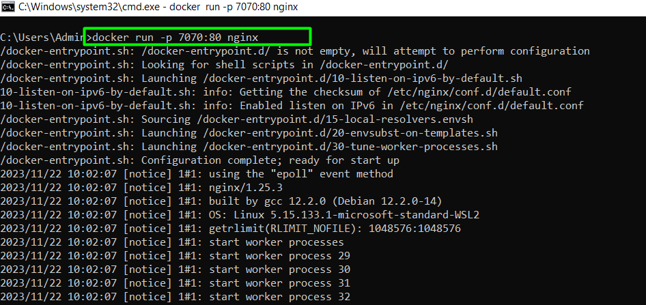

* Pulling **vinsdocker/util** from docker hub, this **vinsdocker/util** image created by udemy instructor the reason we want to execute ping command which is not possible from ubuntu image.

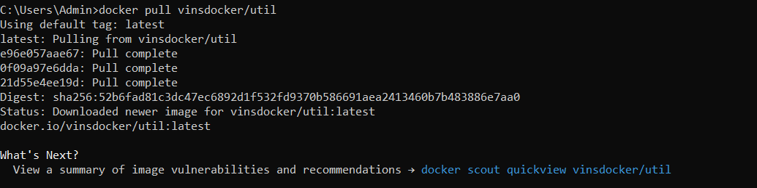

* Execute **inspect** command to know the nginx server IP address. NOTE that **harscore_mestorf** is nginx container name.

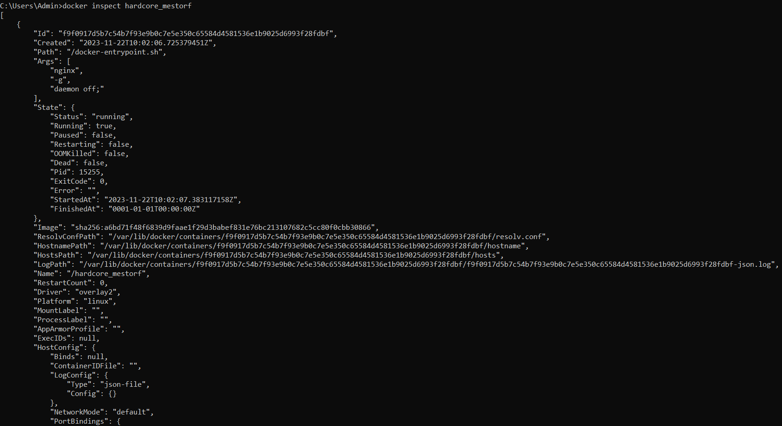

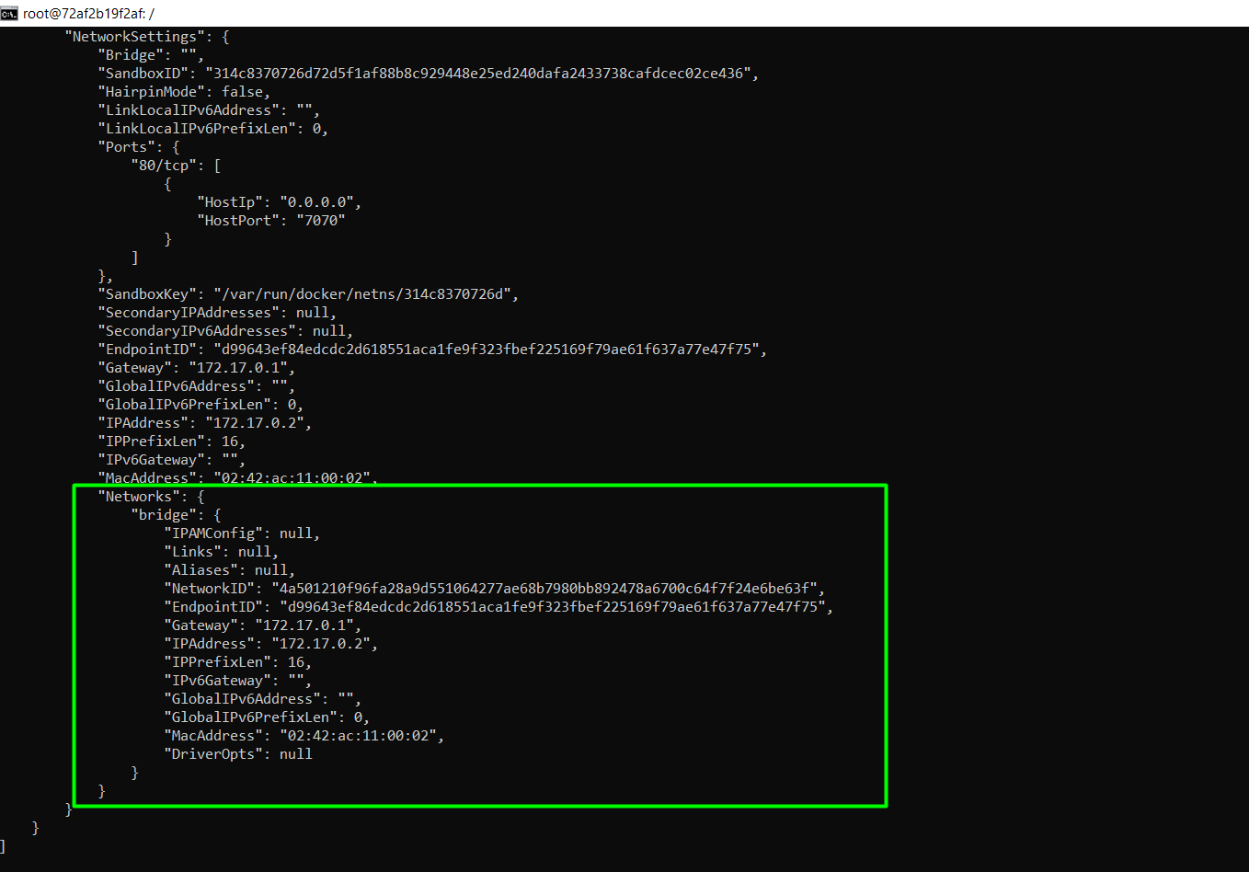

IT is too big output but we only matter Networks tag.

* Invoke vinsdocker image in interactive mode and curl the IP address of nginx

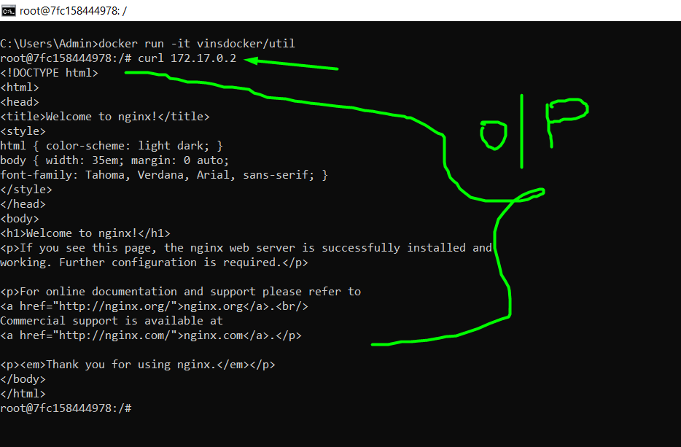

Till now all ok, BUT the problem here is we need to find the IP address of nginx server to ping. So how do we resolve this? Well we can resolve it by using container name instead of IP in ping command but we need to create network for same. Let’s see it in following notes.

List the docker network:

Command: docker network ls

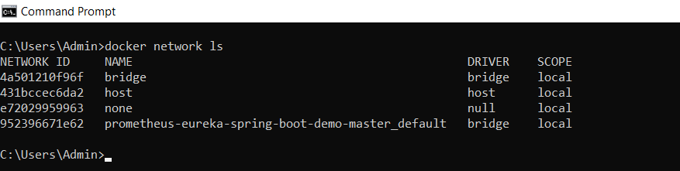

Create network

Command: docker network create dummy_network

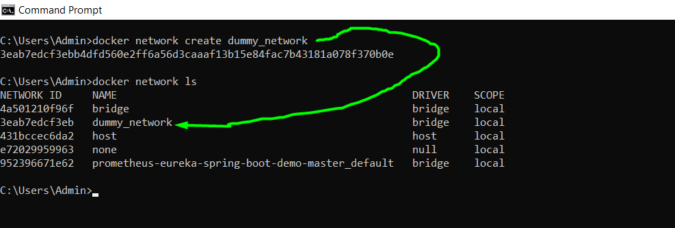

Now run the nginx (with name) and vinsdocker/util in same network

* Nginx

docker run --name=c1 --network=dummy_network -p 7070:80 nginx

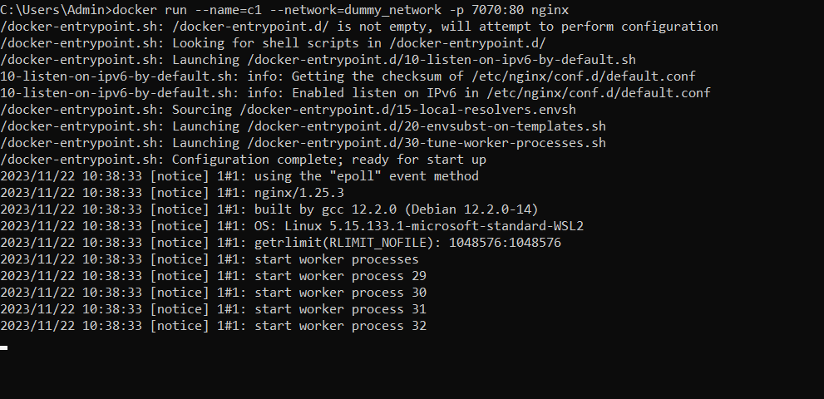

* vinsdocker

docker run -it --network=dummy_network vinsdocker/util

now just invoke curl from vinsdocker/util like below

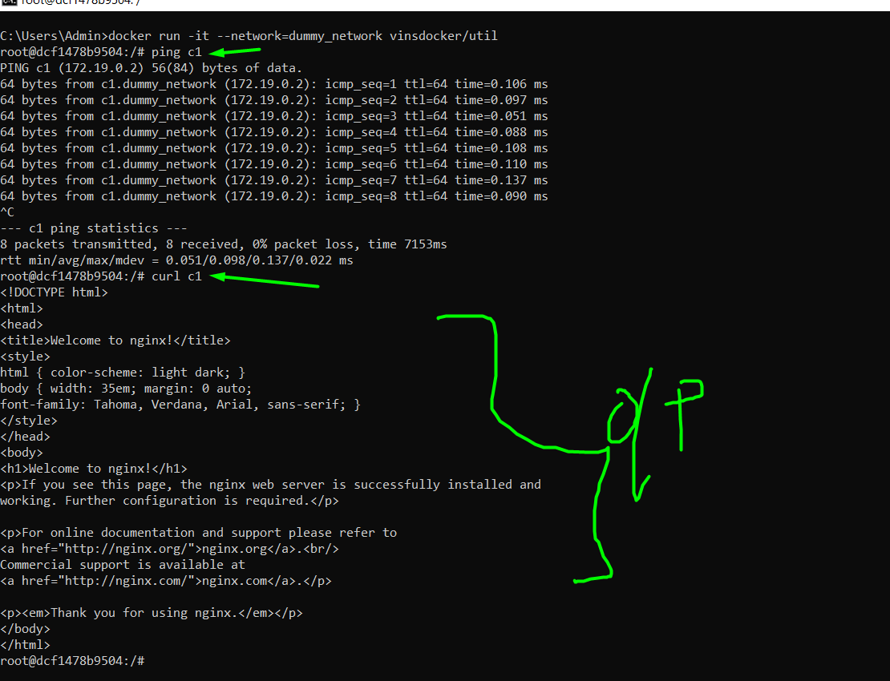

Dockerfile from scratch: Used when we want to create our own image

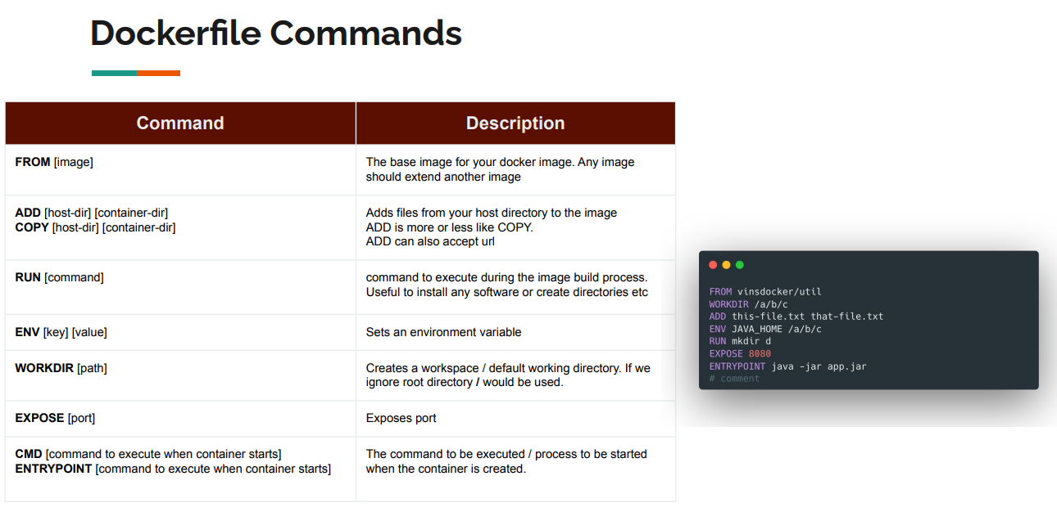

IMP point: Whatever command executed after WORKDIR command those are impacting on WORKDIR. For instance first we set WORKDIR is /a/b/c docker will create directory called “a/b/c”. After that ADD command will add the this-file.txt by renaming i.e that-file.txt under “a/b/c” directory.

Steps to create docker file

Navigate to your working directly & create custom file like welcome.txt. welcome.txt contains only welcome message.

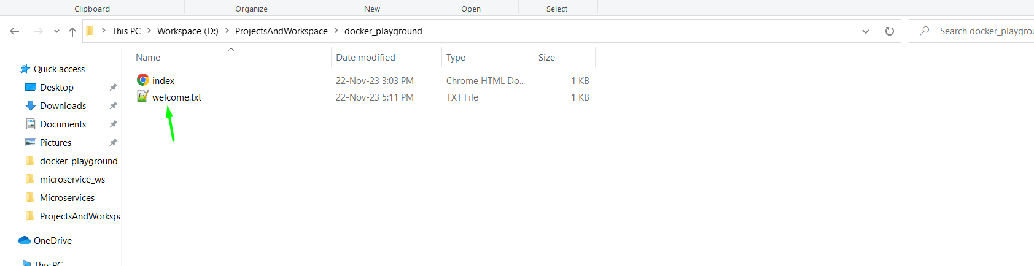

Create docker file like below without any extension

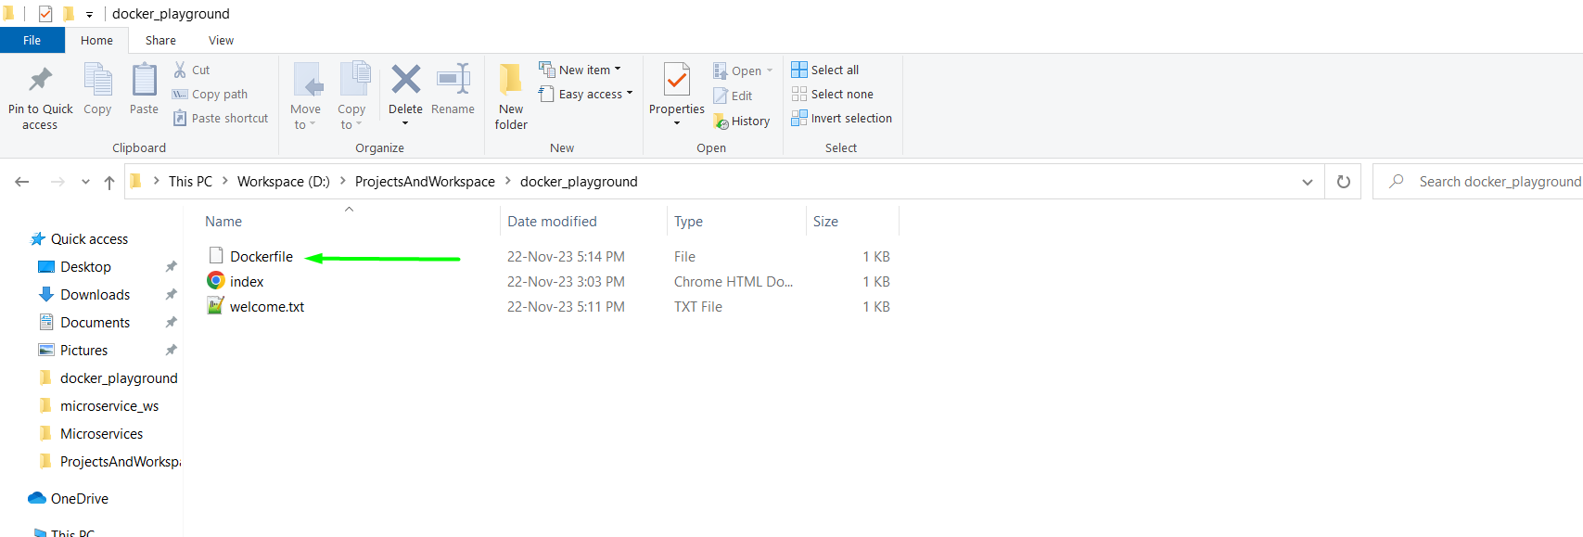

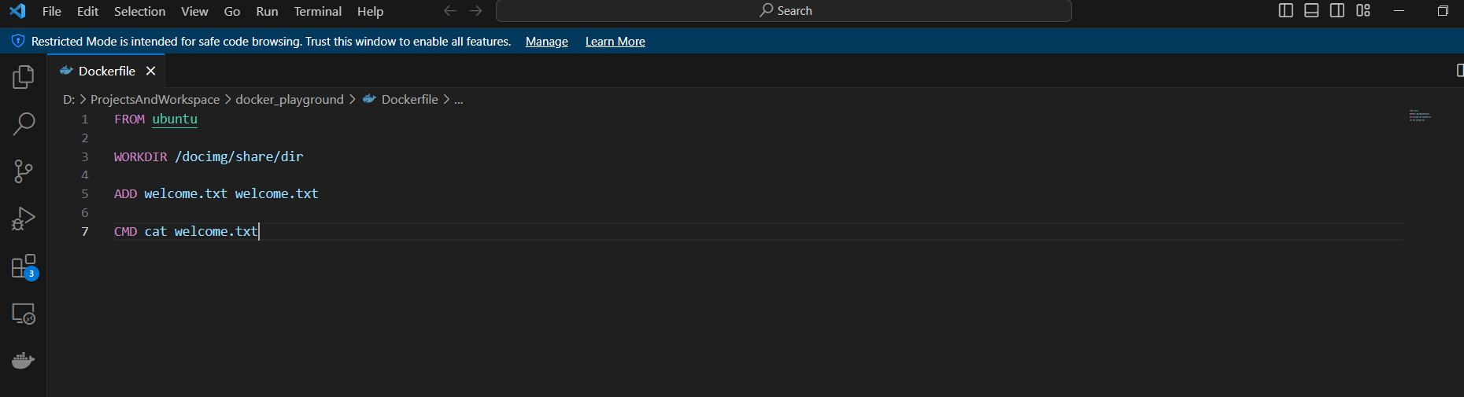

Now let’s understand the commands.

FROM ubuntu > it tells this image will be child of ubuntu image

WORKDIR /docimg/share/dir > It means create custom docimg/share/dir directory

ADD welcome.txt welcome.txt > it will add welcome.txt to docimg/share/dir directory

CMD cat welcome.txt > CMD used when container is actually up and running. So basically here we are just printing the text from welcome.txt when container got run.

Build the image

Command: docker build -t my-hello-world .

-t : build and tag the image

my-hello-world: image name

. : path where Dockerfile is present

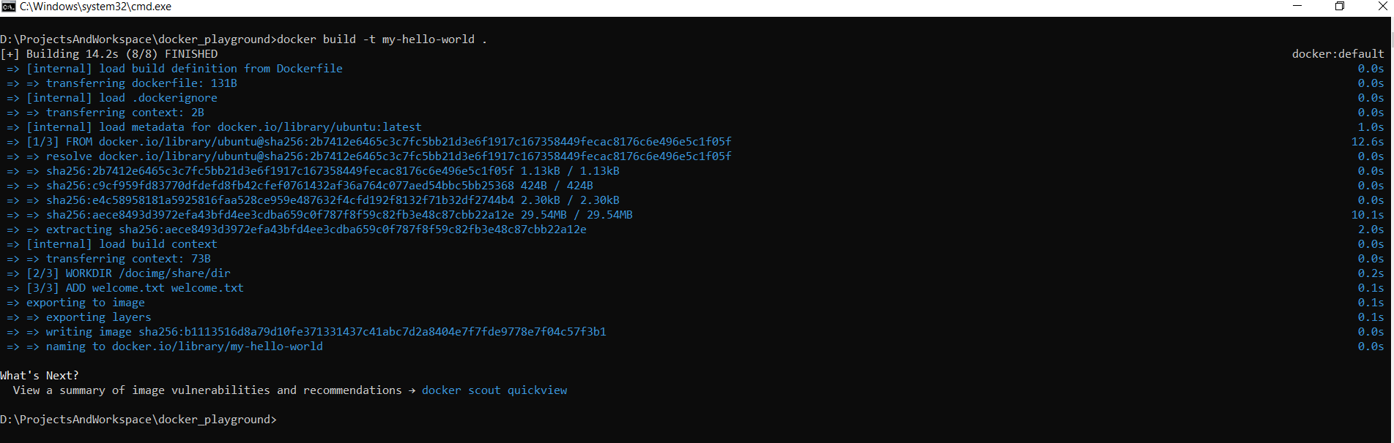

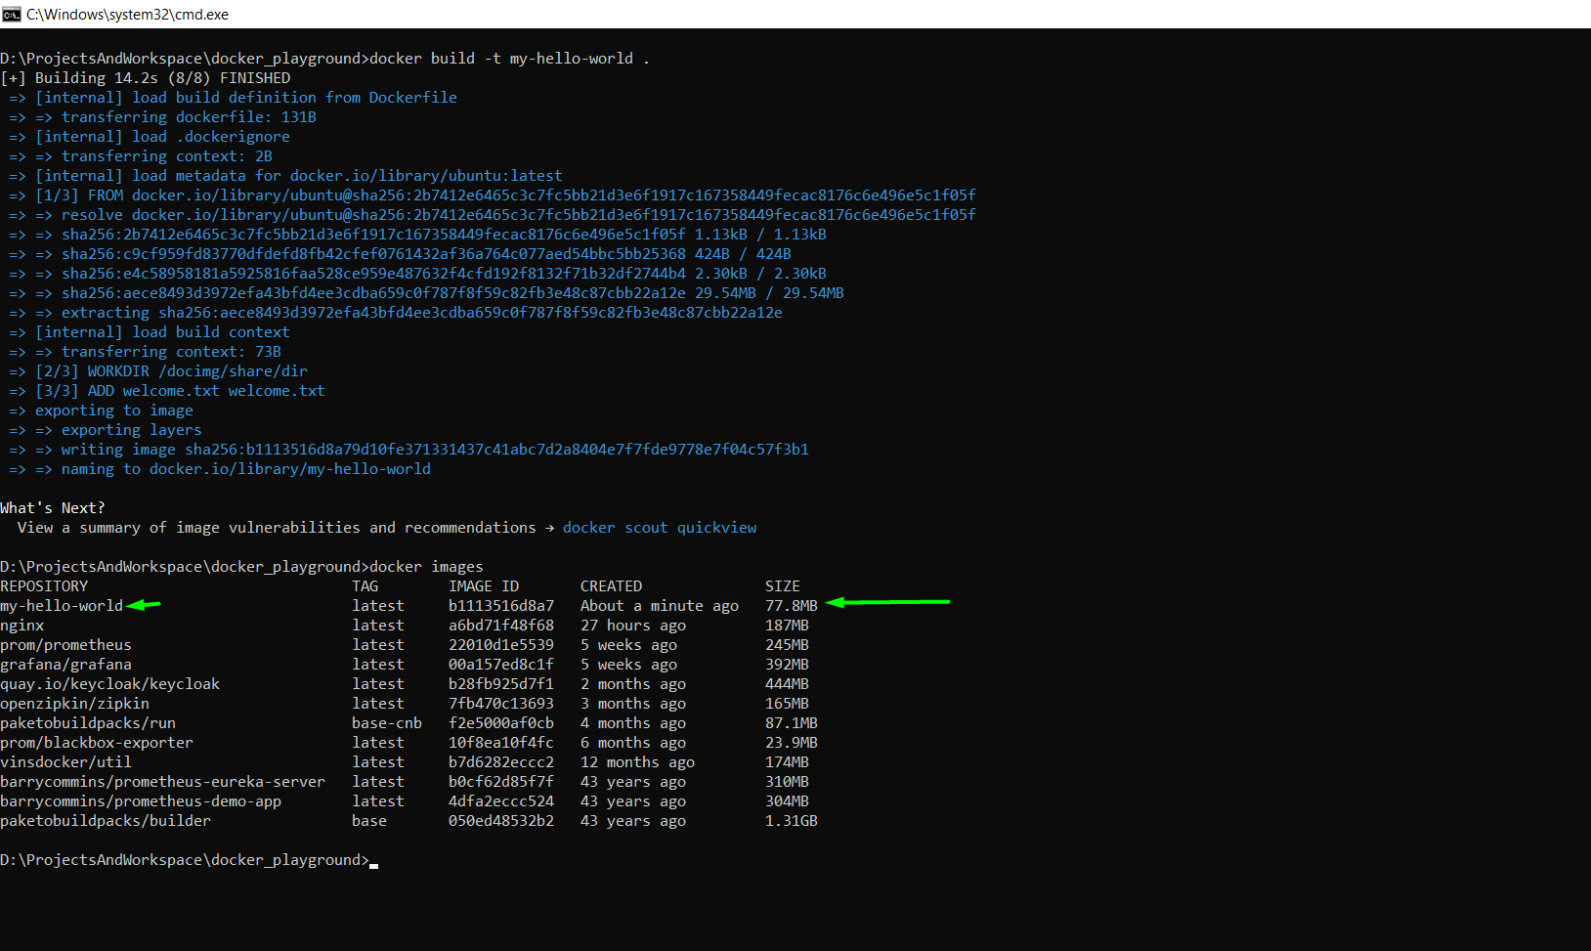

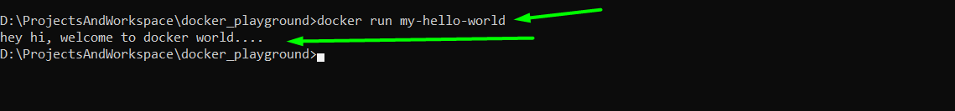

Exploring docker image:

Run image In interactive mode but provide bash, on turning on interactive mode the system will take you to the WORKDIR i.e /docimg/share/dir

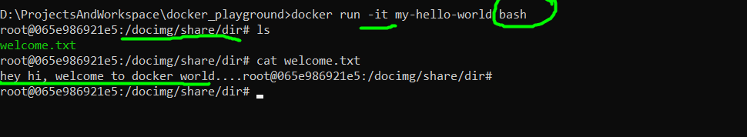

Install jdk to ubuntu image:

Run the ubuntu image

* docker run -it ubuntu
  + ubuntu image will run in interactive mode

We may need to update and install curl packages

* type below command on interactive mode
  + apt-get update
  + apt-get **install curl**

Now using curl command download the jdk zip file like below

* curl [https://download.java.net/java/GA/jdk21.0.1/415e3f918a1f4062a0074a2794853d0d/12/GPL/openjdk-21.0.1_linux-x64_bin.tar.gz --open jdk-21.tar.zip](https://download.java.net/java/GA/jdk21.0.1/415e3f918a1f4062a0074a2794853d0d/12/GPL/openjdk-21.0.1_linux-x64_bin.tar.gz%20--open%20jdk-21.tar.zip)
* Here –open option tells the downloaded content should packed into file name jdk-21.tar.zip

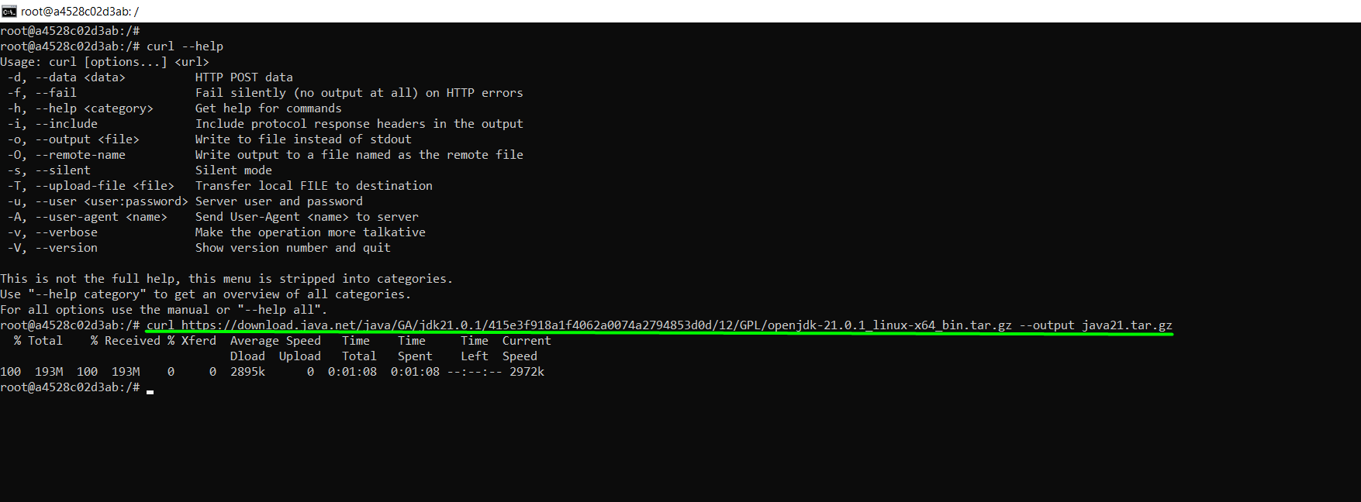

Now extract the java21.tar.gz using below command

* tar -xvzf java21.tar.gz

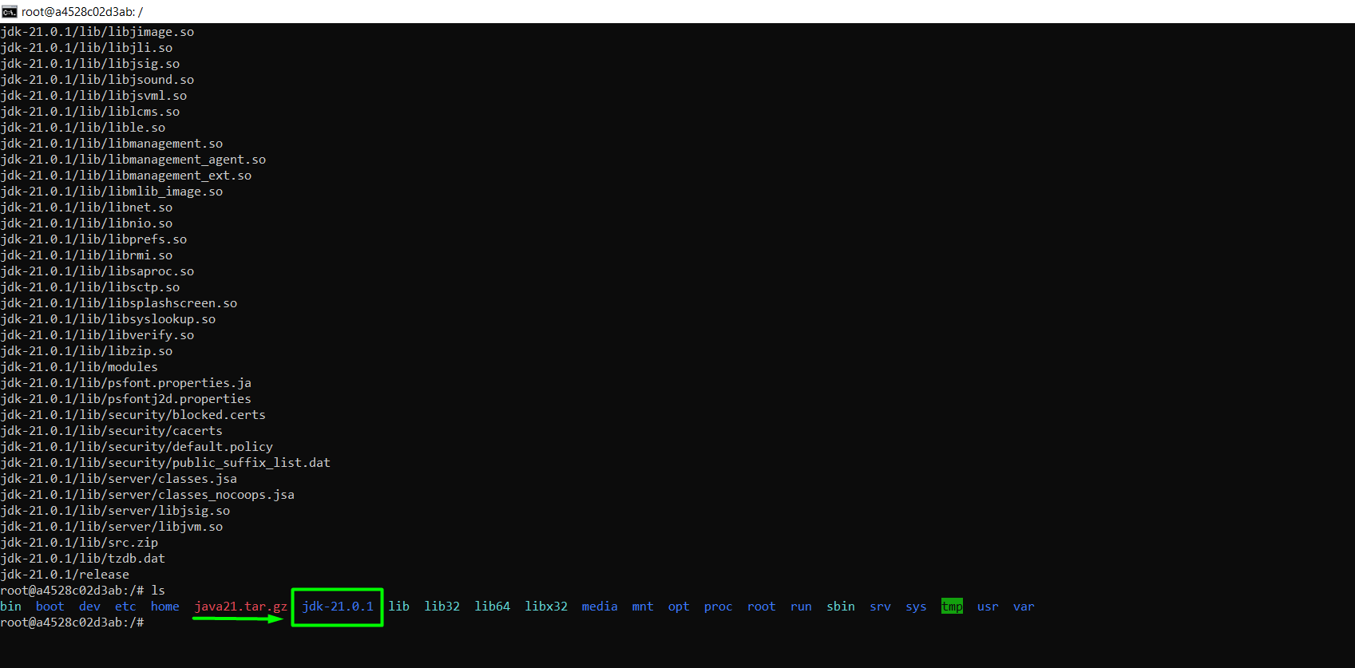

Now remove java21.tar.gz

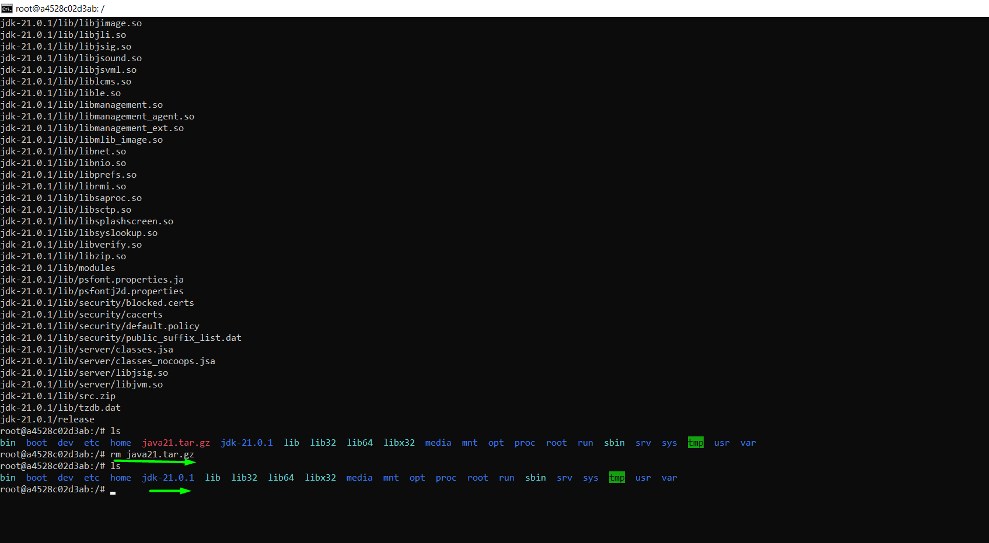

Check java version

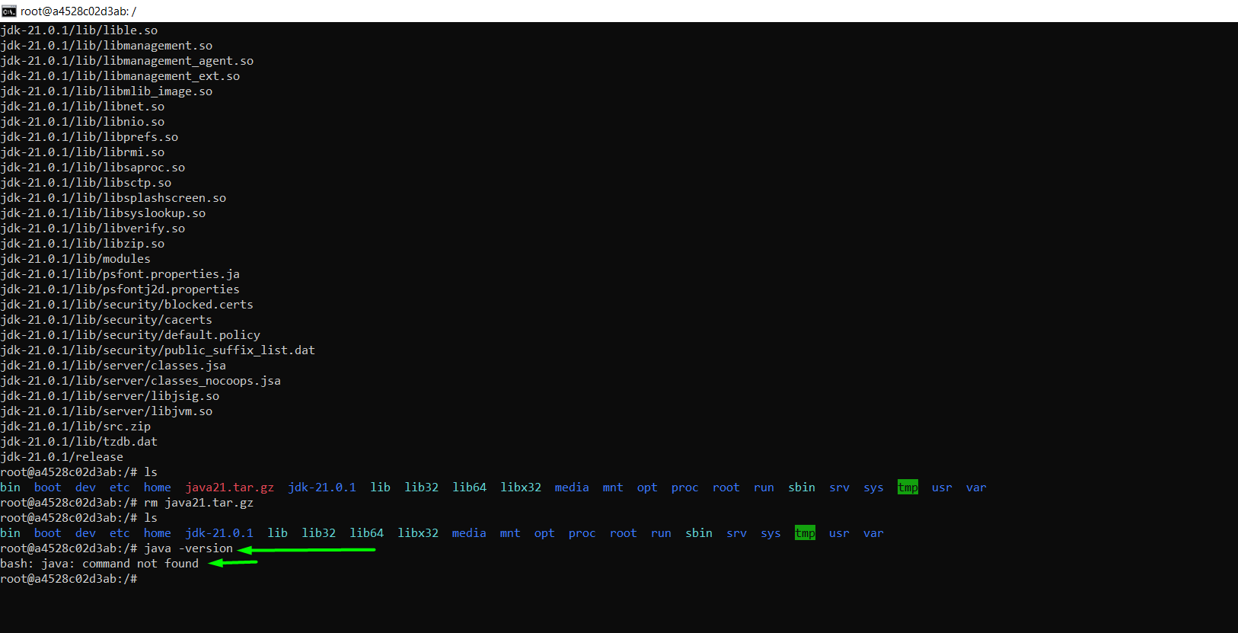

As you can see java command is not found, the reason is we don’t have java in path.

Set java into path

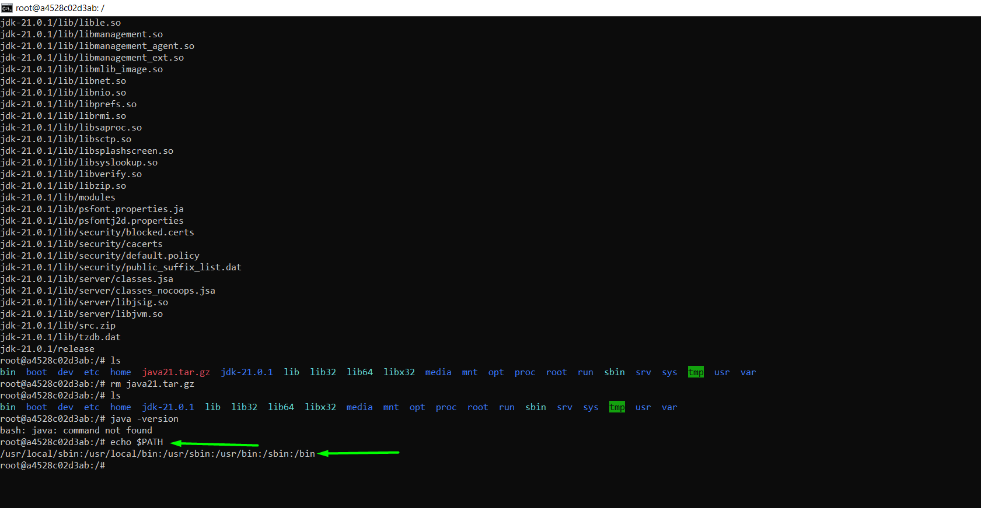

Navigate to /jdk-21.0.1/bin and export the path like below

* export PATH=$PATH:jdk-21.0.1/bin

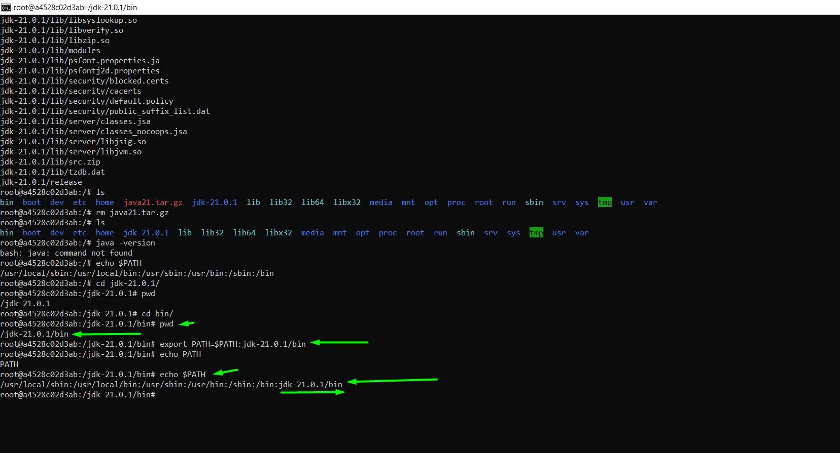

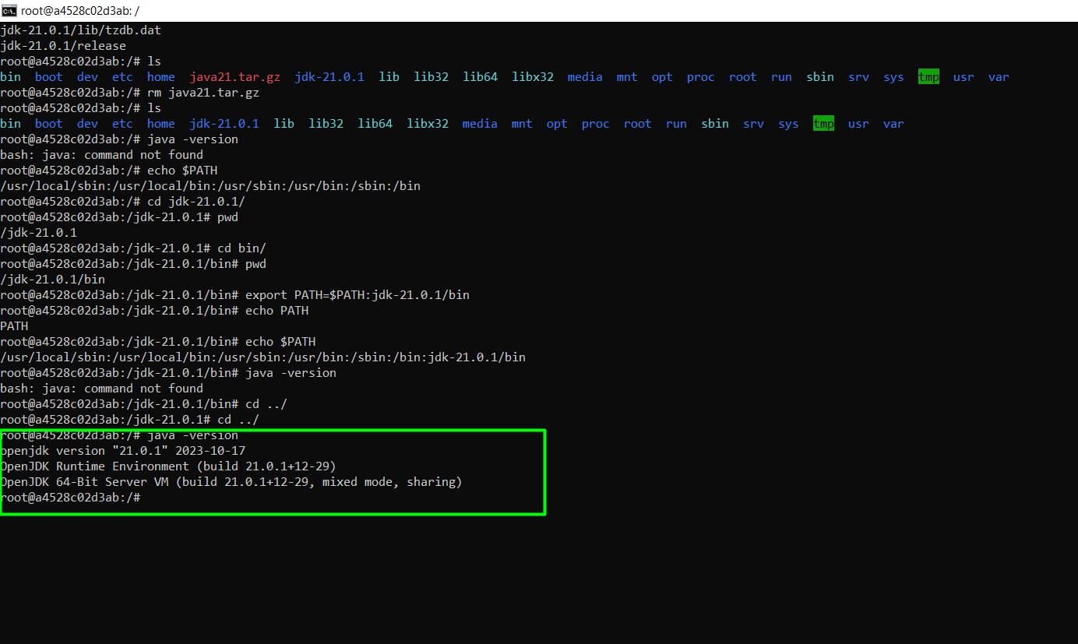

Task: create custom docker image which is based on ubuntu and it has java 21 installed.

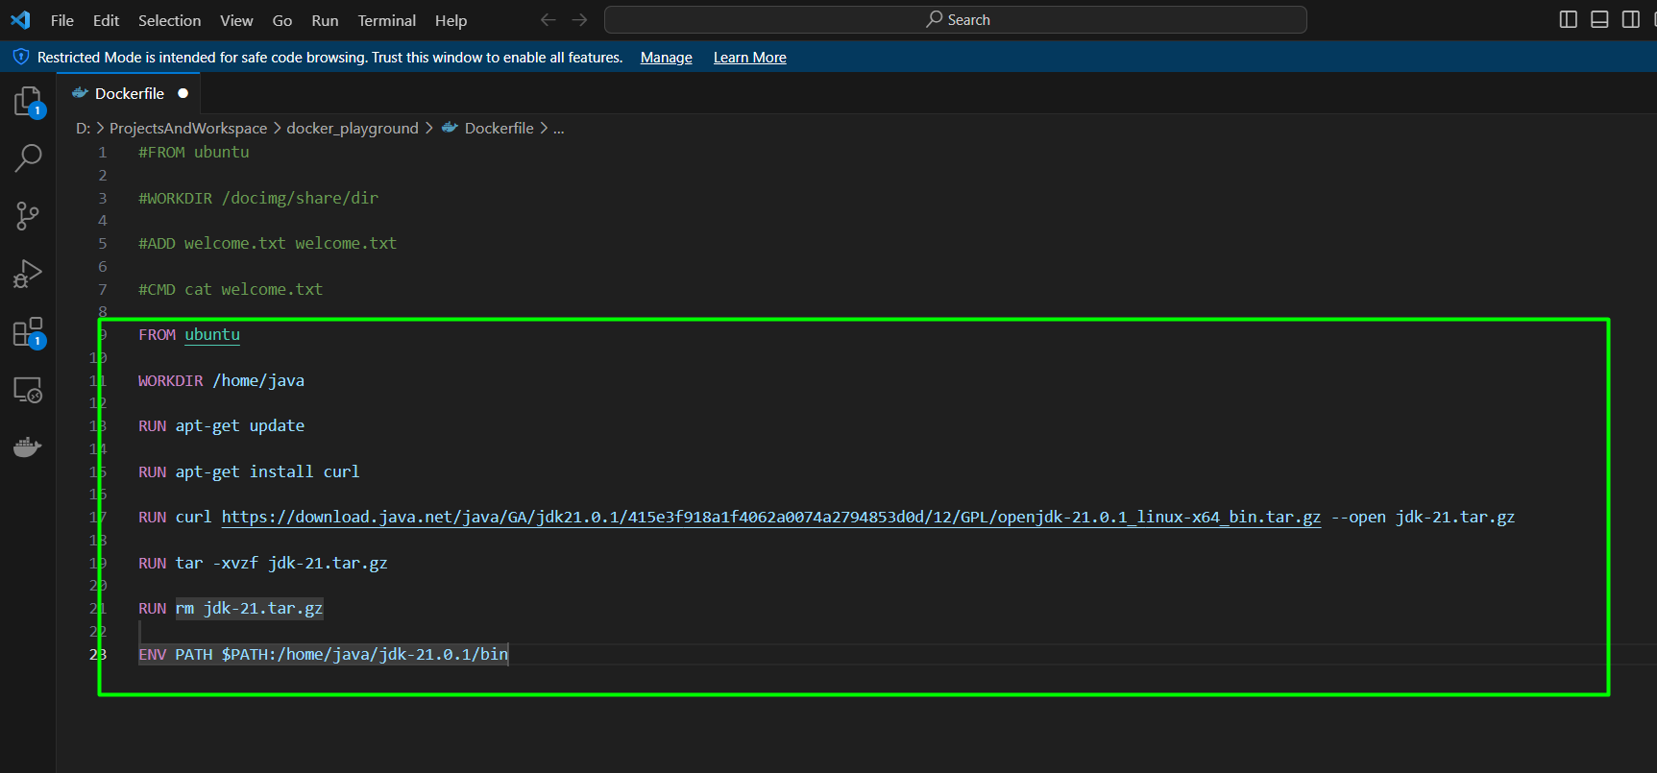

Save and build the image



Build is fail

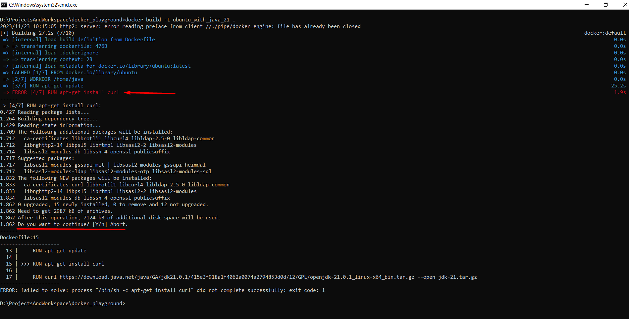

The reason is while manually installation we manually provide **y** as option, in same we need to provide it in Dockerfile like below.

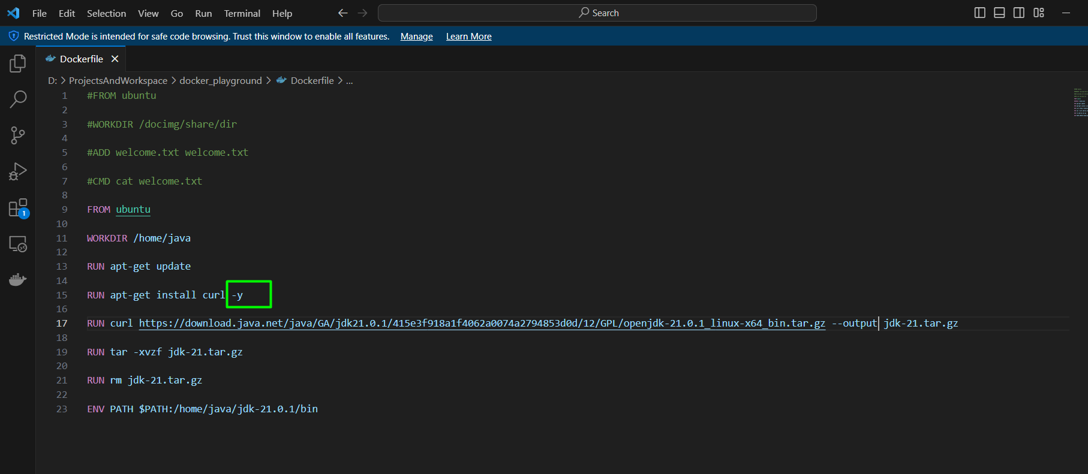

Re build

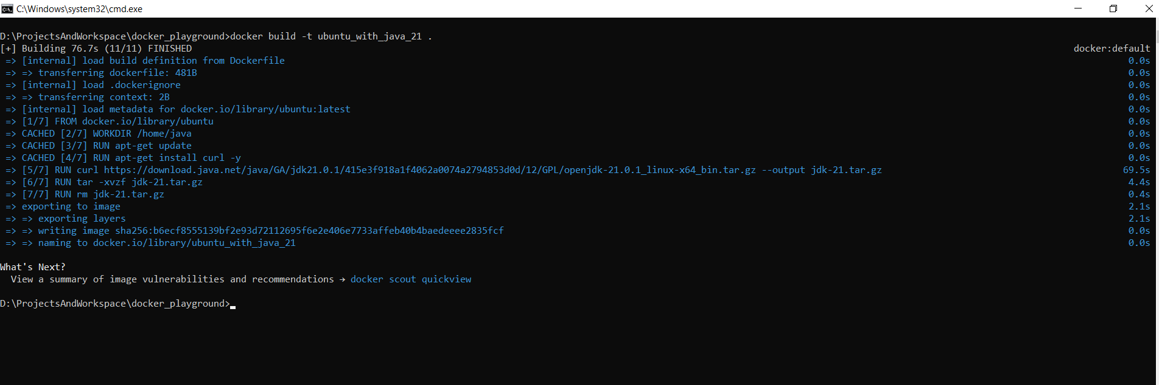

Now run the image in interactive mode and check the java version

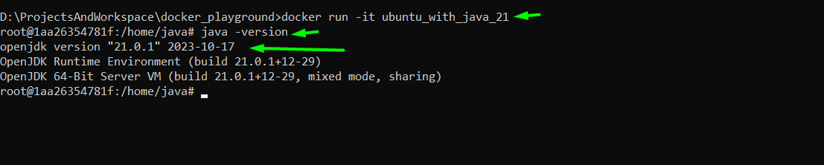

Scenario: Write a docker image which will have java file that taking/reading environment variable value.

Write a java program

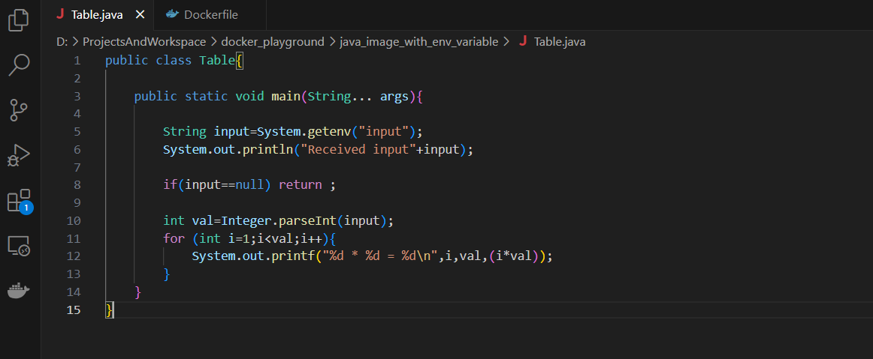

Write a docker file like

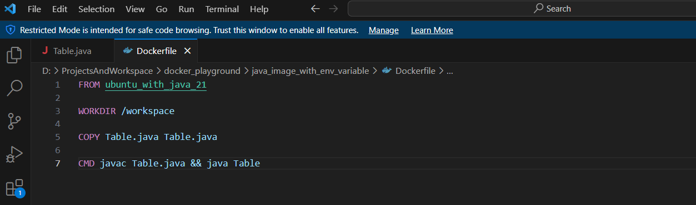

Build the image

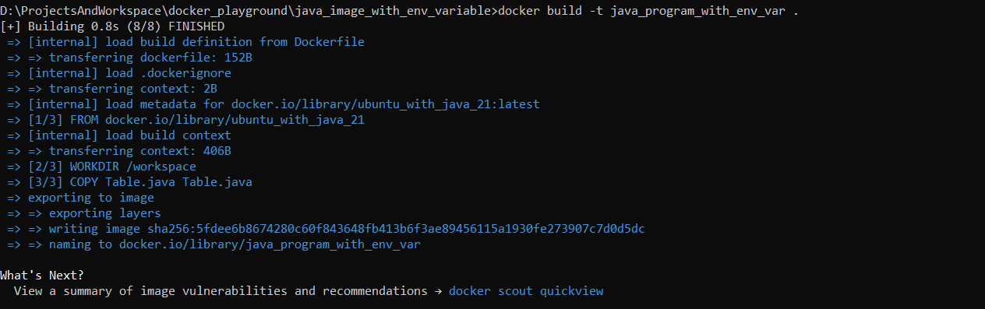

Run the image without env variable



Run the image with env variable

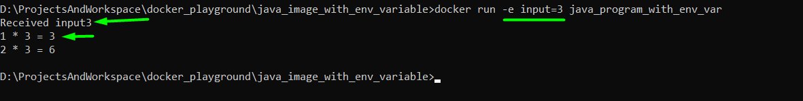

Passing multiple arguments



# Docker compose

Some theory

File:

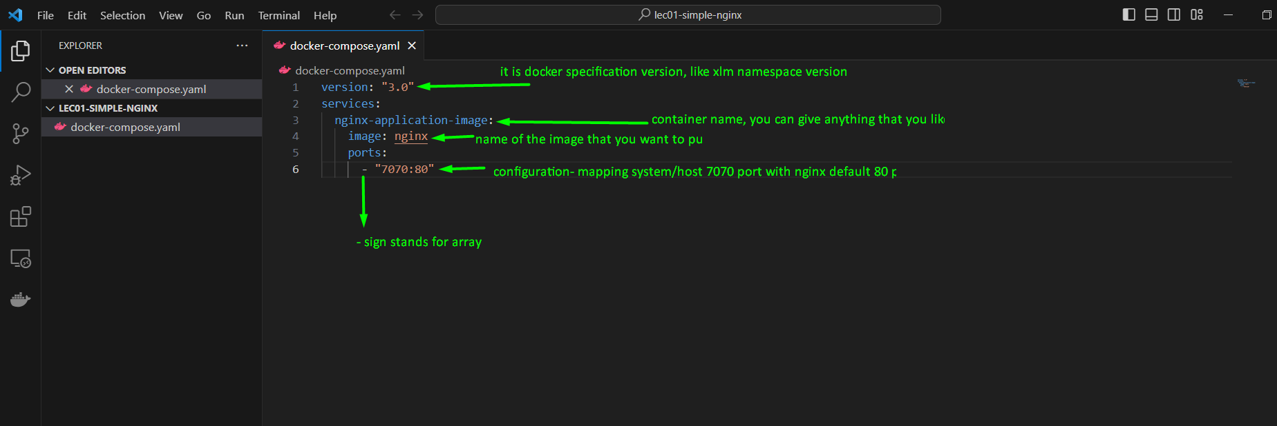

Command: docker-compose up

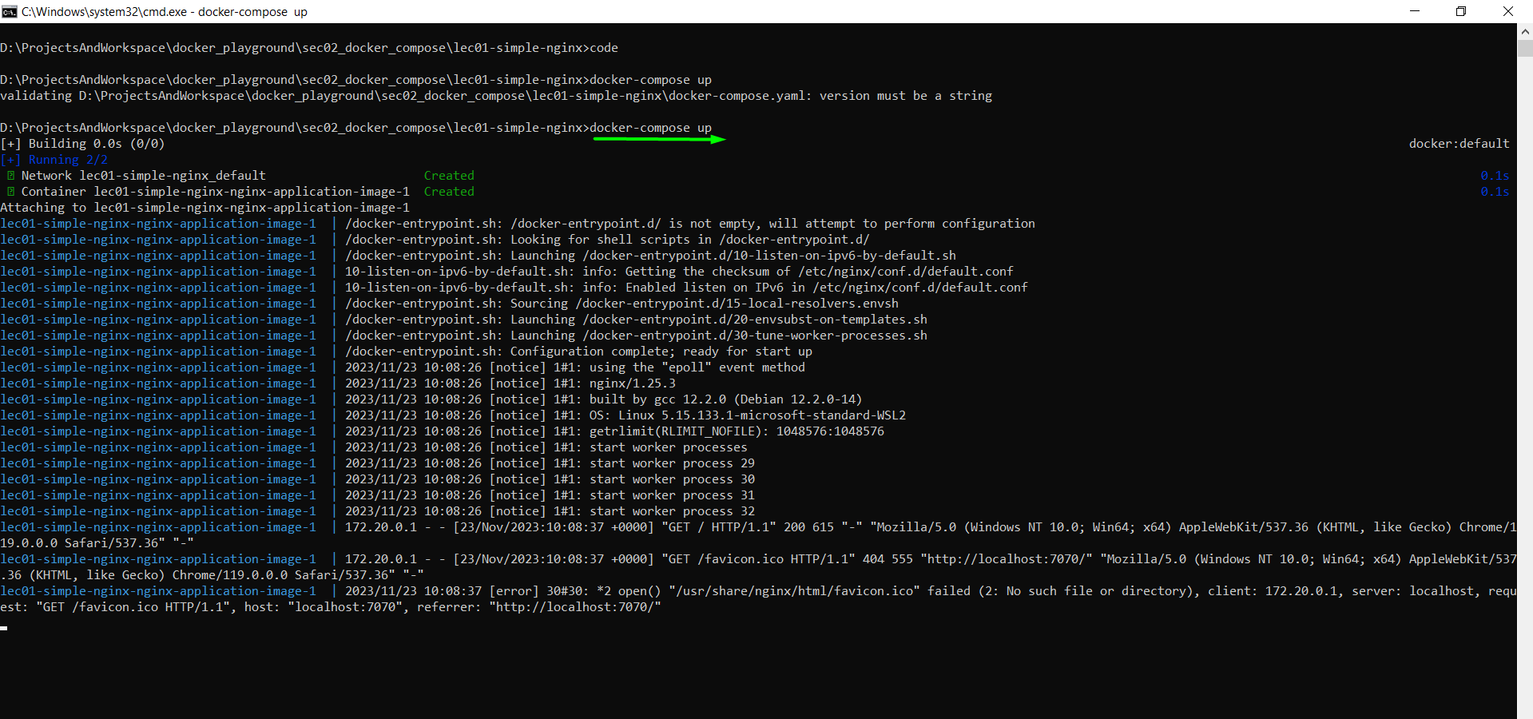

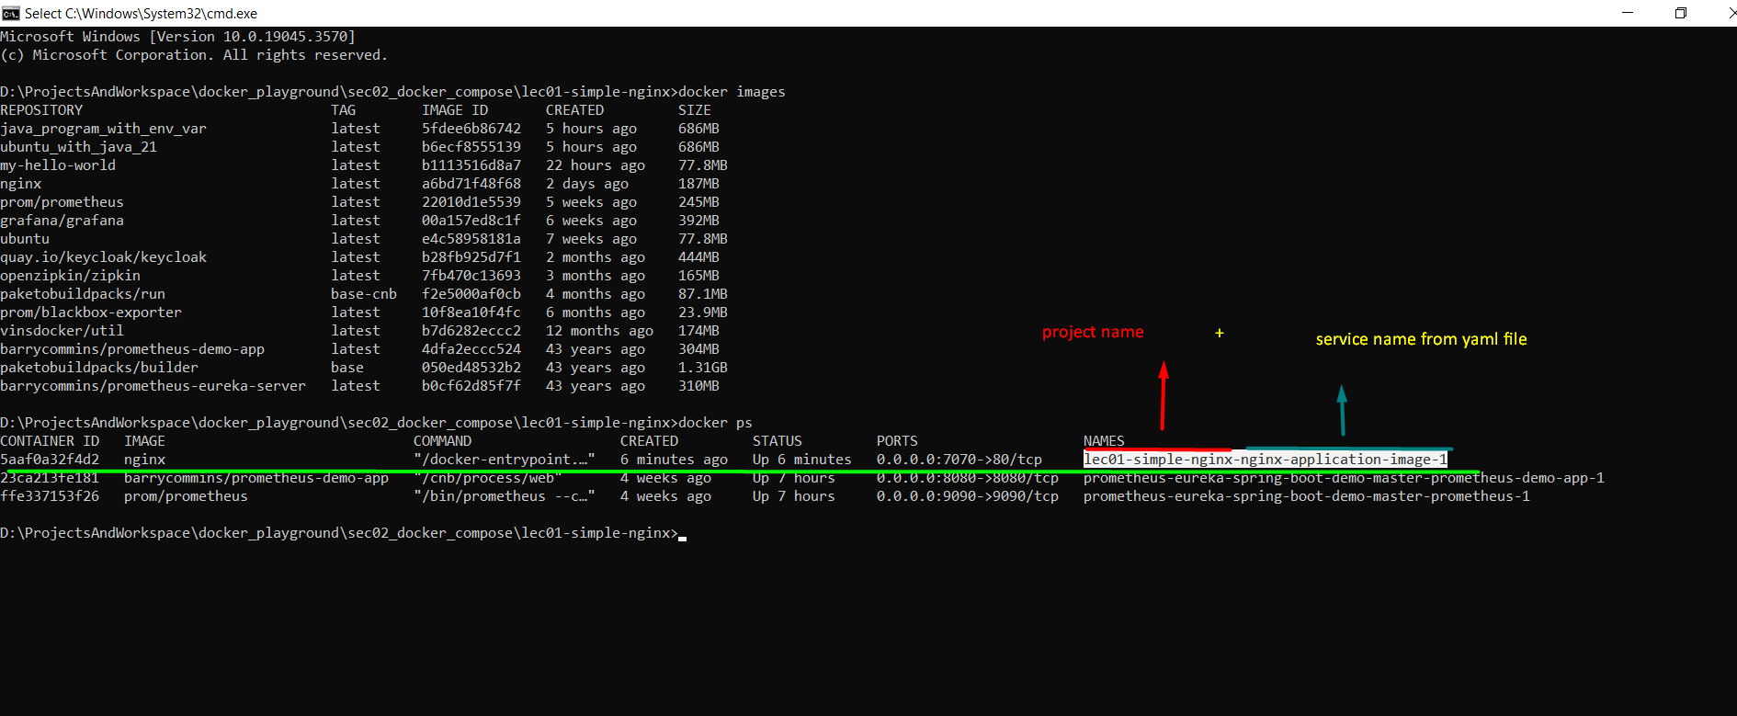

Access the server page:

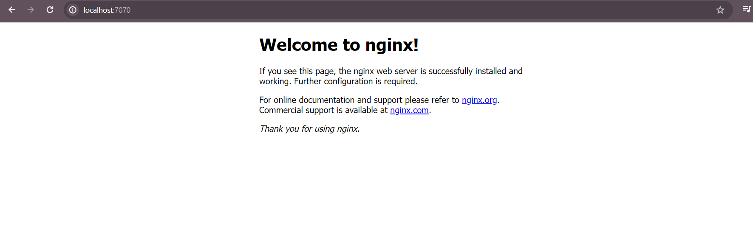

Docker-compose down – used to remove container and network

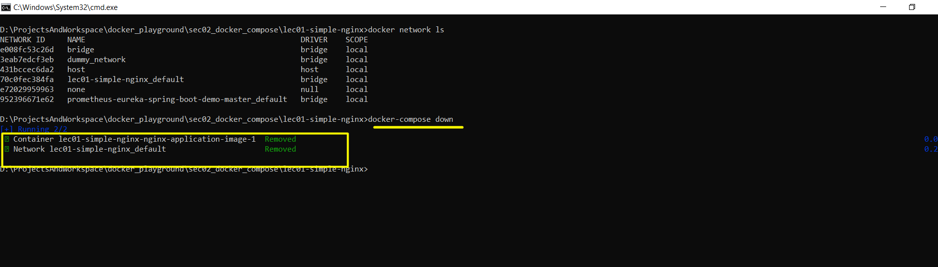

NOTE:

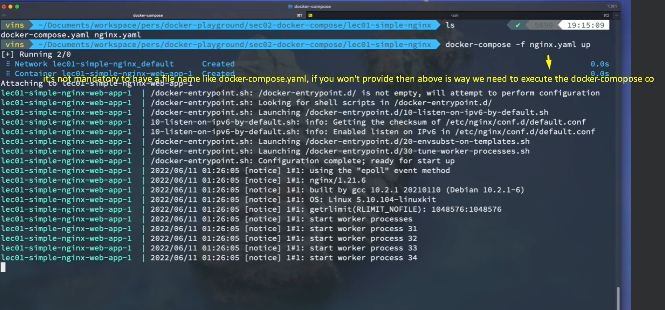

# Docker-compose volume mapping

Please see the changes:

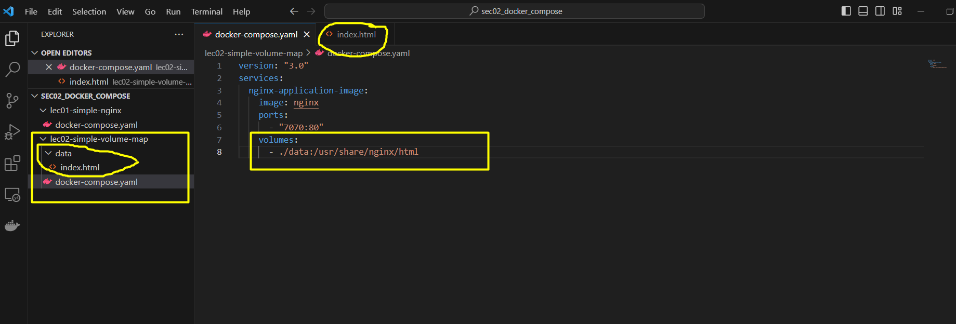

Docker-compose up command

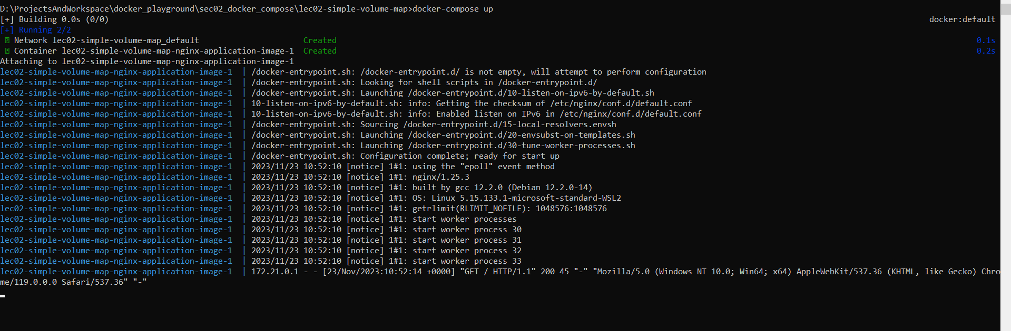

Accessing the home page

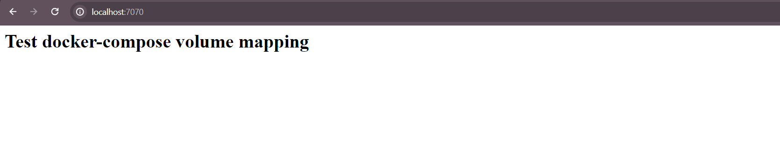

# Docker-compose network

Some theory

Please see the image for proper understanding

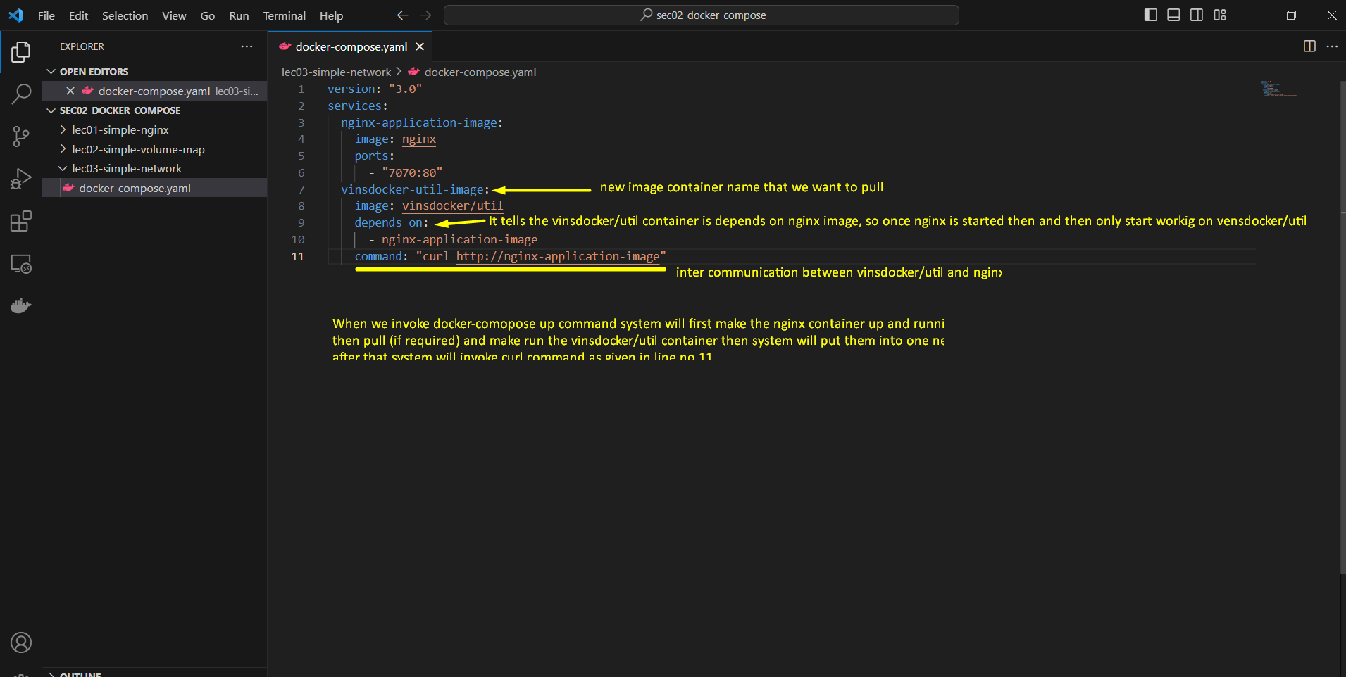

# Docker-compose environment variable:

Environment variable without docker compose

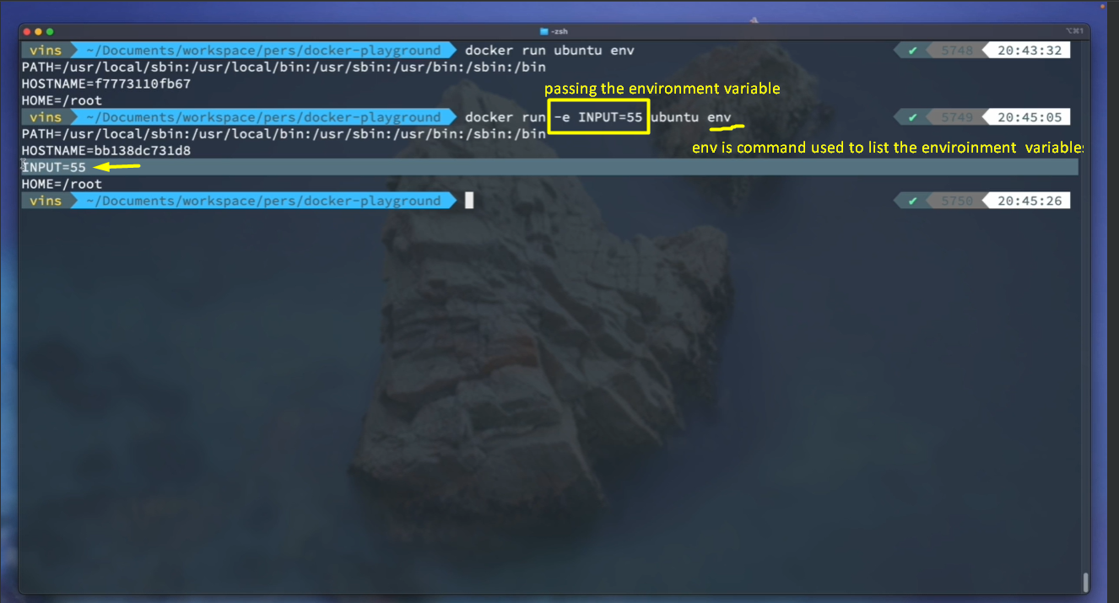

In above example we are running ubuntu image by passing INPUT=55 as env variable and then listing all environment variables using “env” command.

So how do we going to achieve same thing using docker-compose?

* Here is the compose file

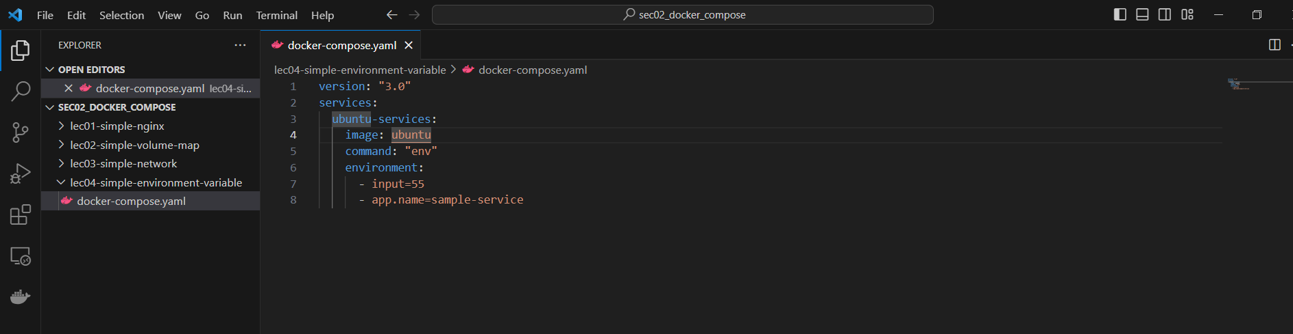

After docker-compose

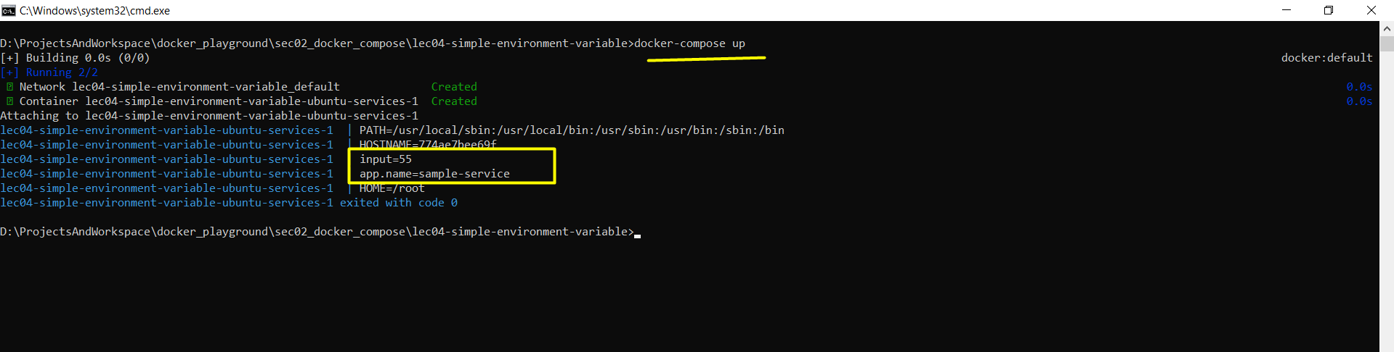

Using environment file

Step 1: Add file

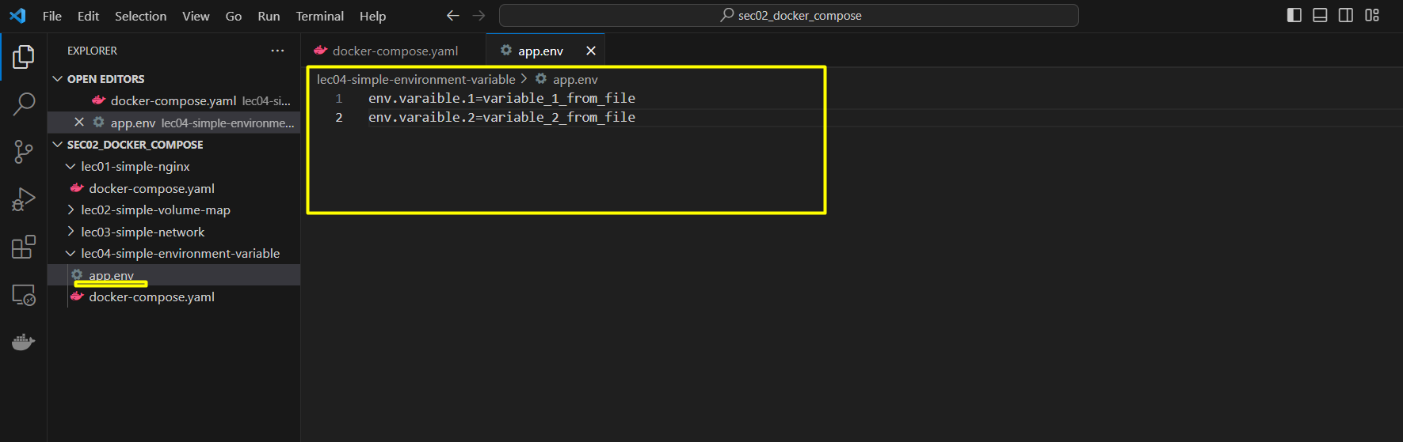

Step 2: provide file

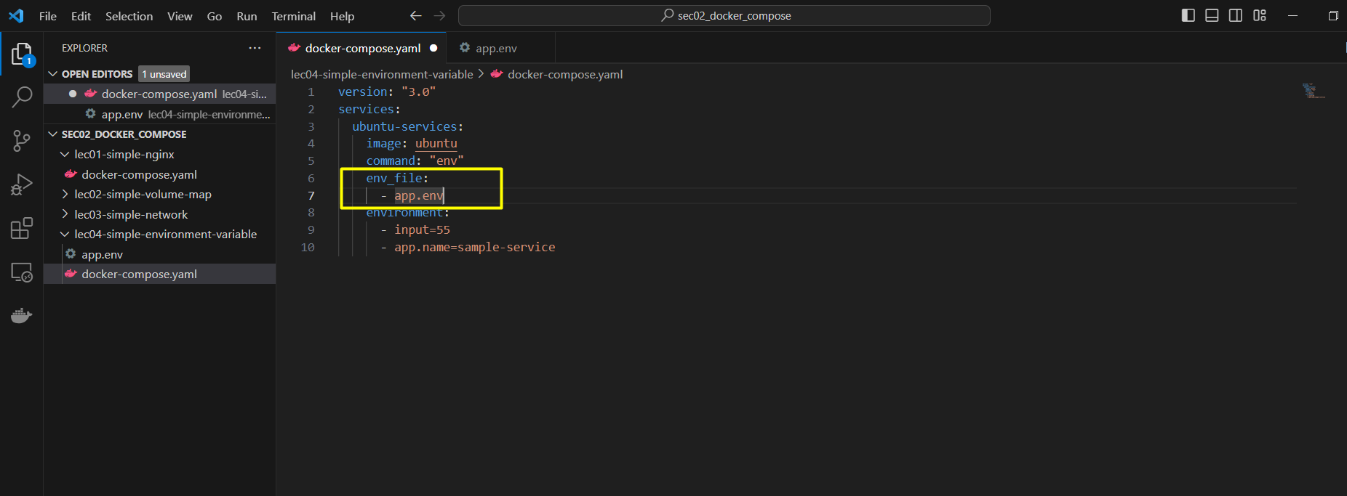

After docker-compose up

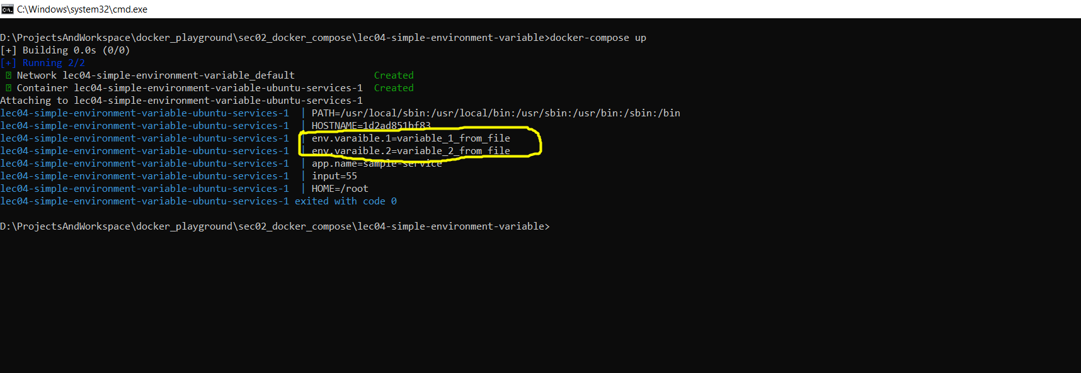

## Mongo DB and mongo express example using docker-compose:

Mongo-express is the UI for mongo DB

Configuration:

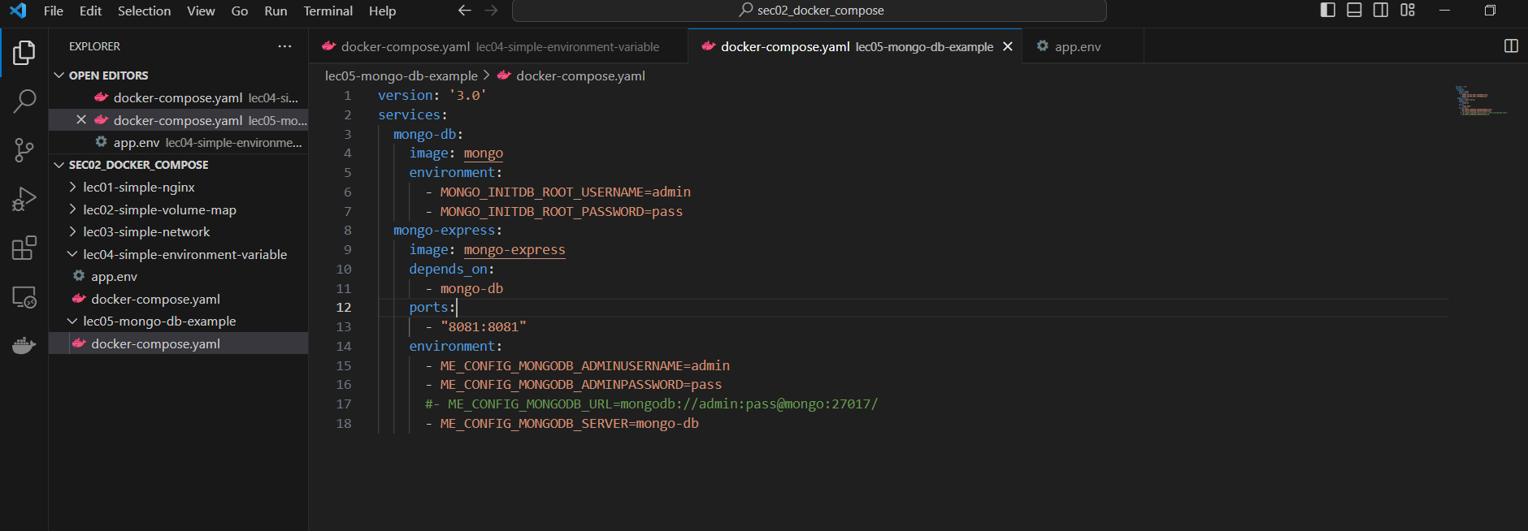

After docker compose up

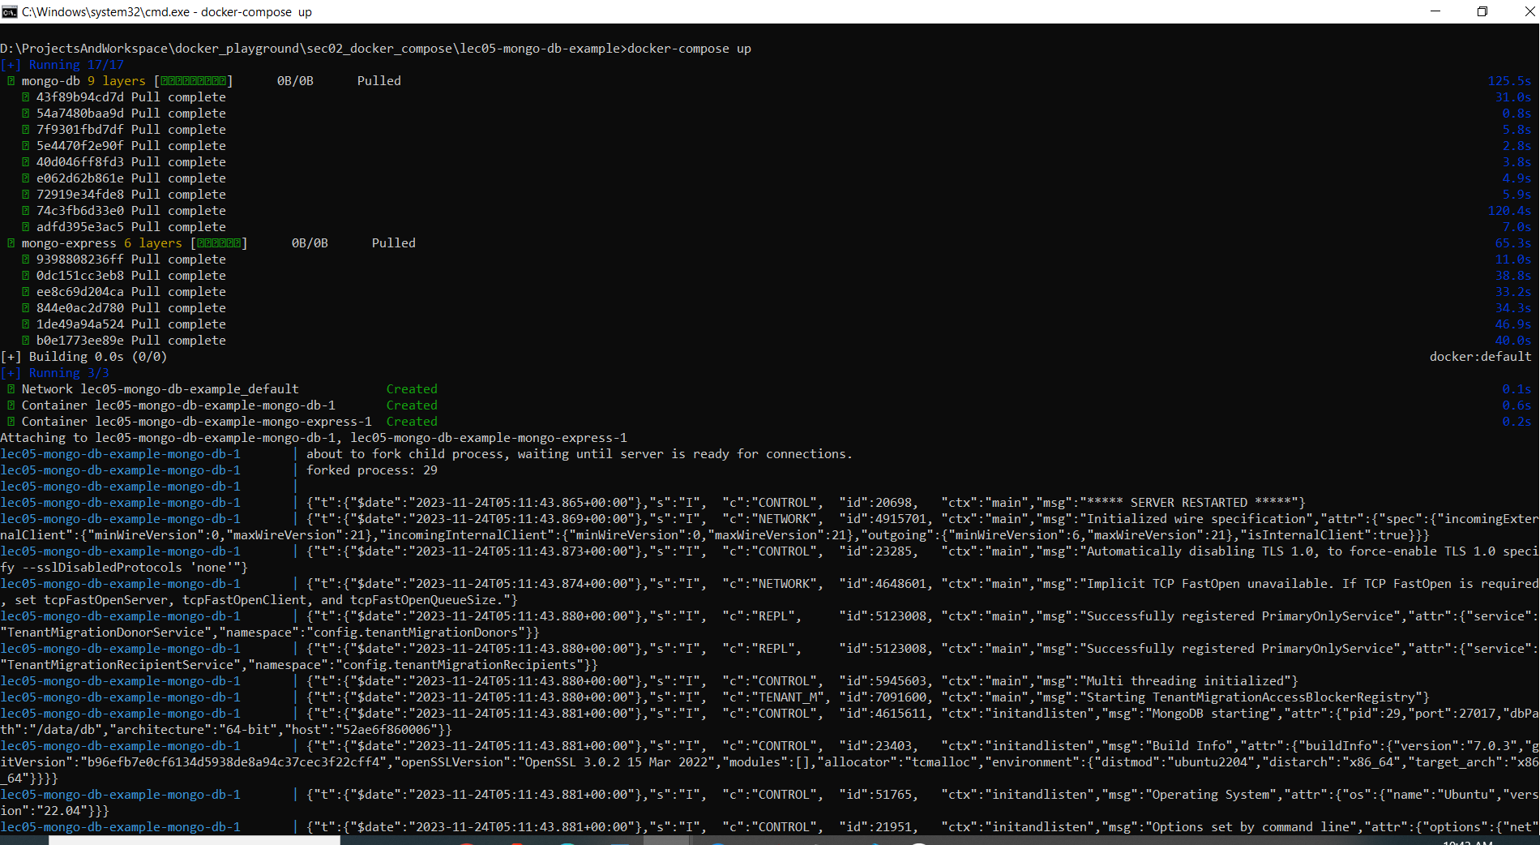

List the container

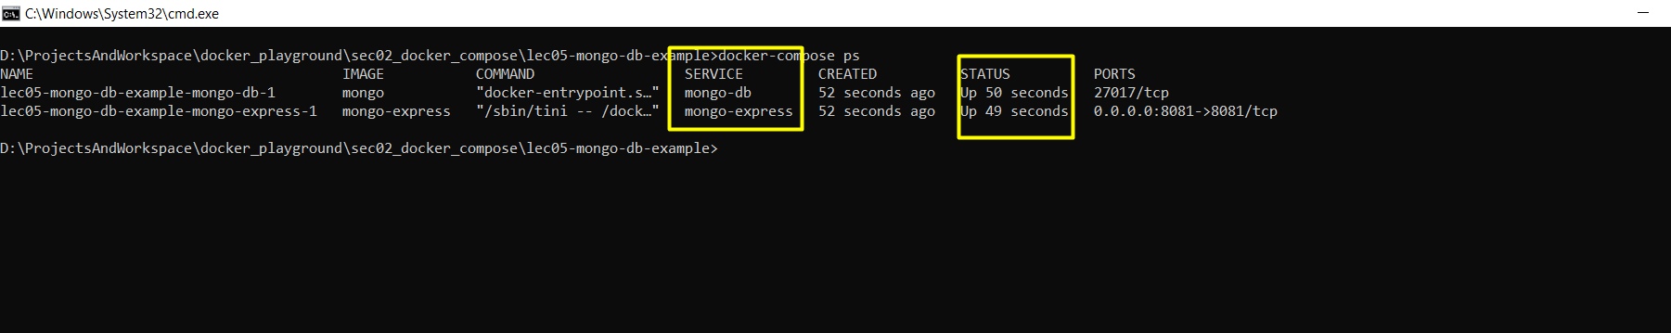

Now access the mongo-express UI:

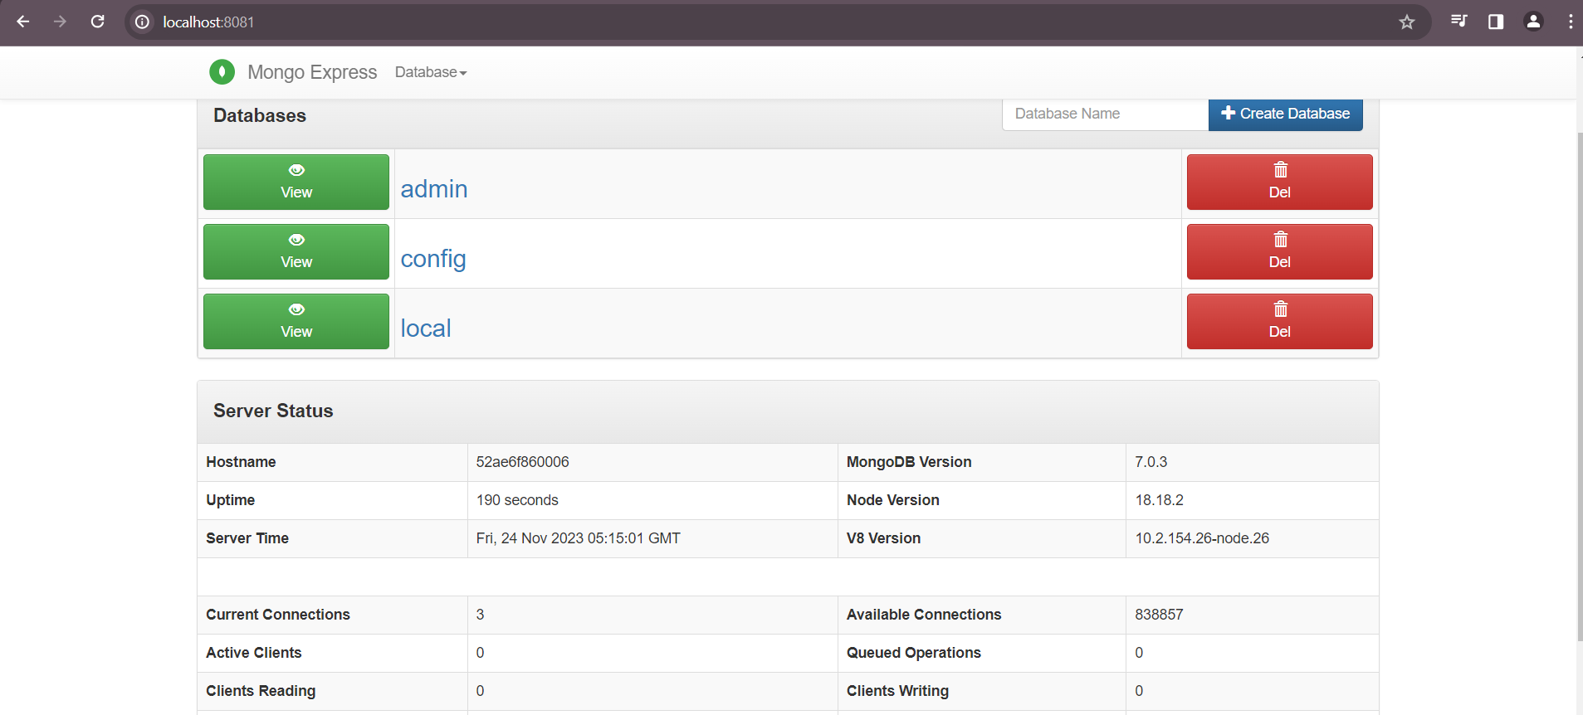

IMP: Sometimes mongo-express application container up and start making request to mongo db container but mongo db is still in his basic setup i.e not yet ready to serve the facility or services and hence mongo-express container failed to start. This problem we can still face even though we are using **depends_on:.** To resolve this we can re-write configuration as bellow:

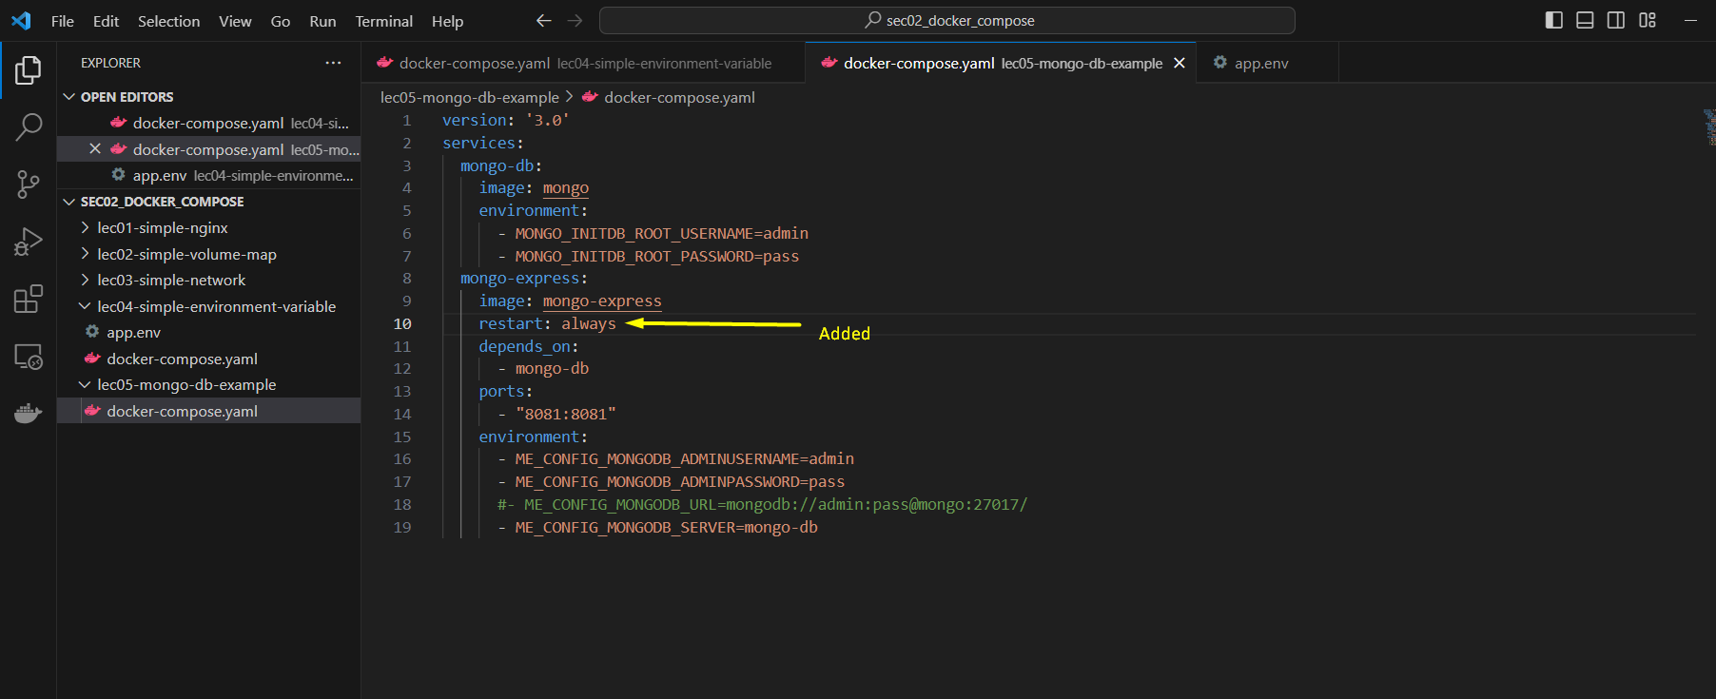

Ref for more detail: Udemy course- Docker From Scratch [2023 - For Java Developers] – 59. MongoDB / Mongo Express – Part 2

# Mongo persistence: (docker-compose with volumes)

Issue: as soon as you stop or remove the container all saved data is vanish so we need to store the data into host machine.

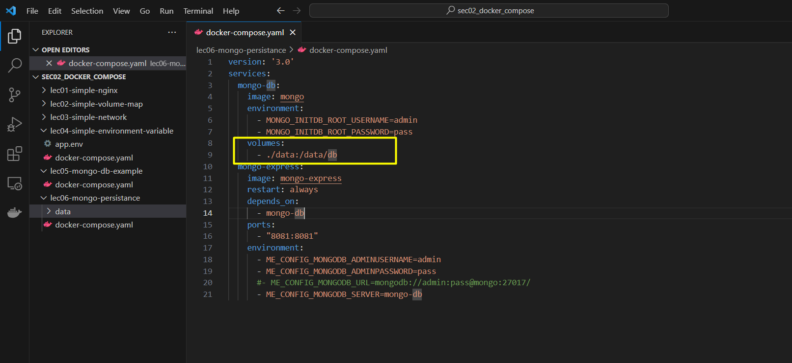

After docker-compose

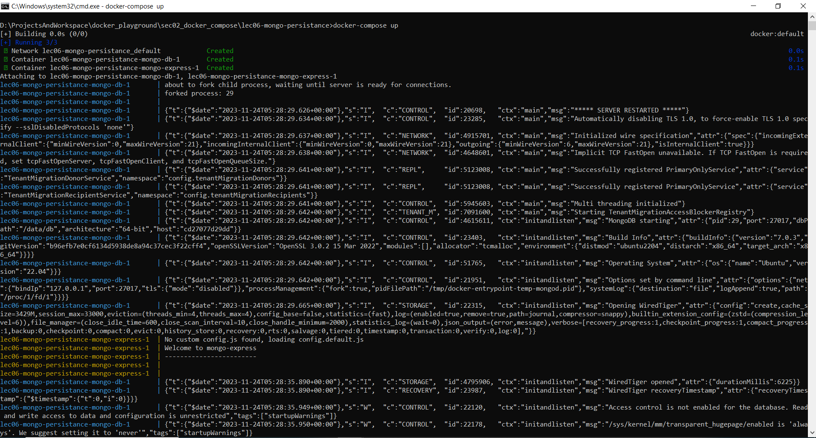

Host directory:

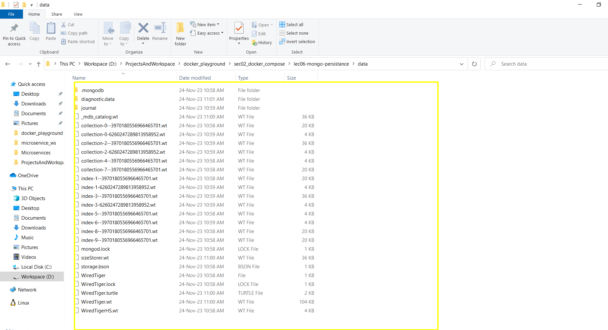

Access mongo-express UI and create DB and document

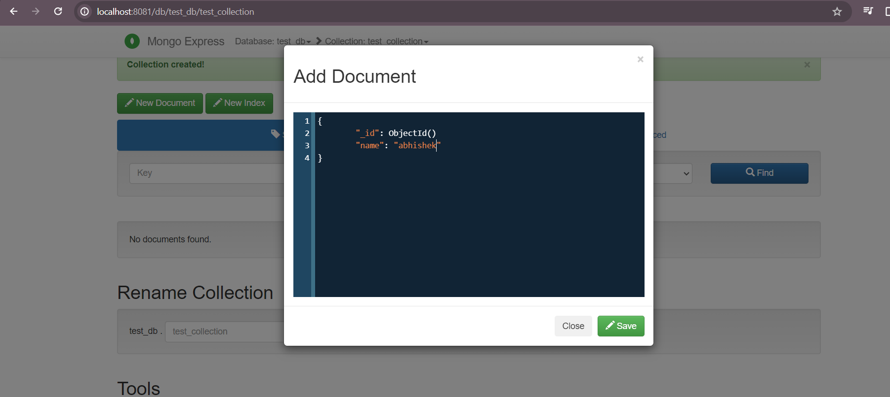

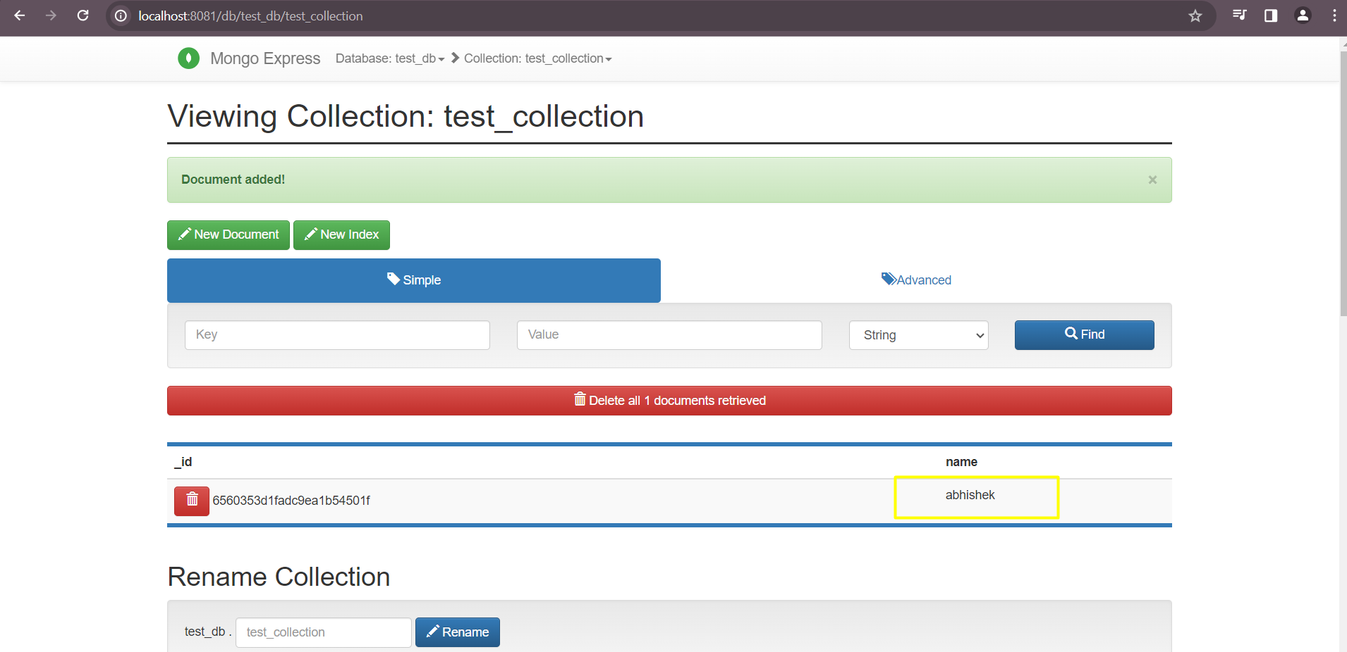

Now stop the container and execute docker-compose down so that all container will get removed.

Stoped

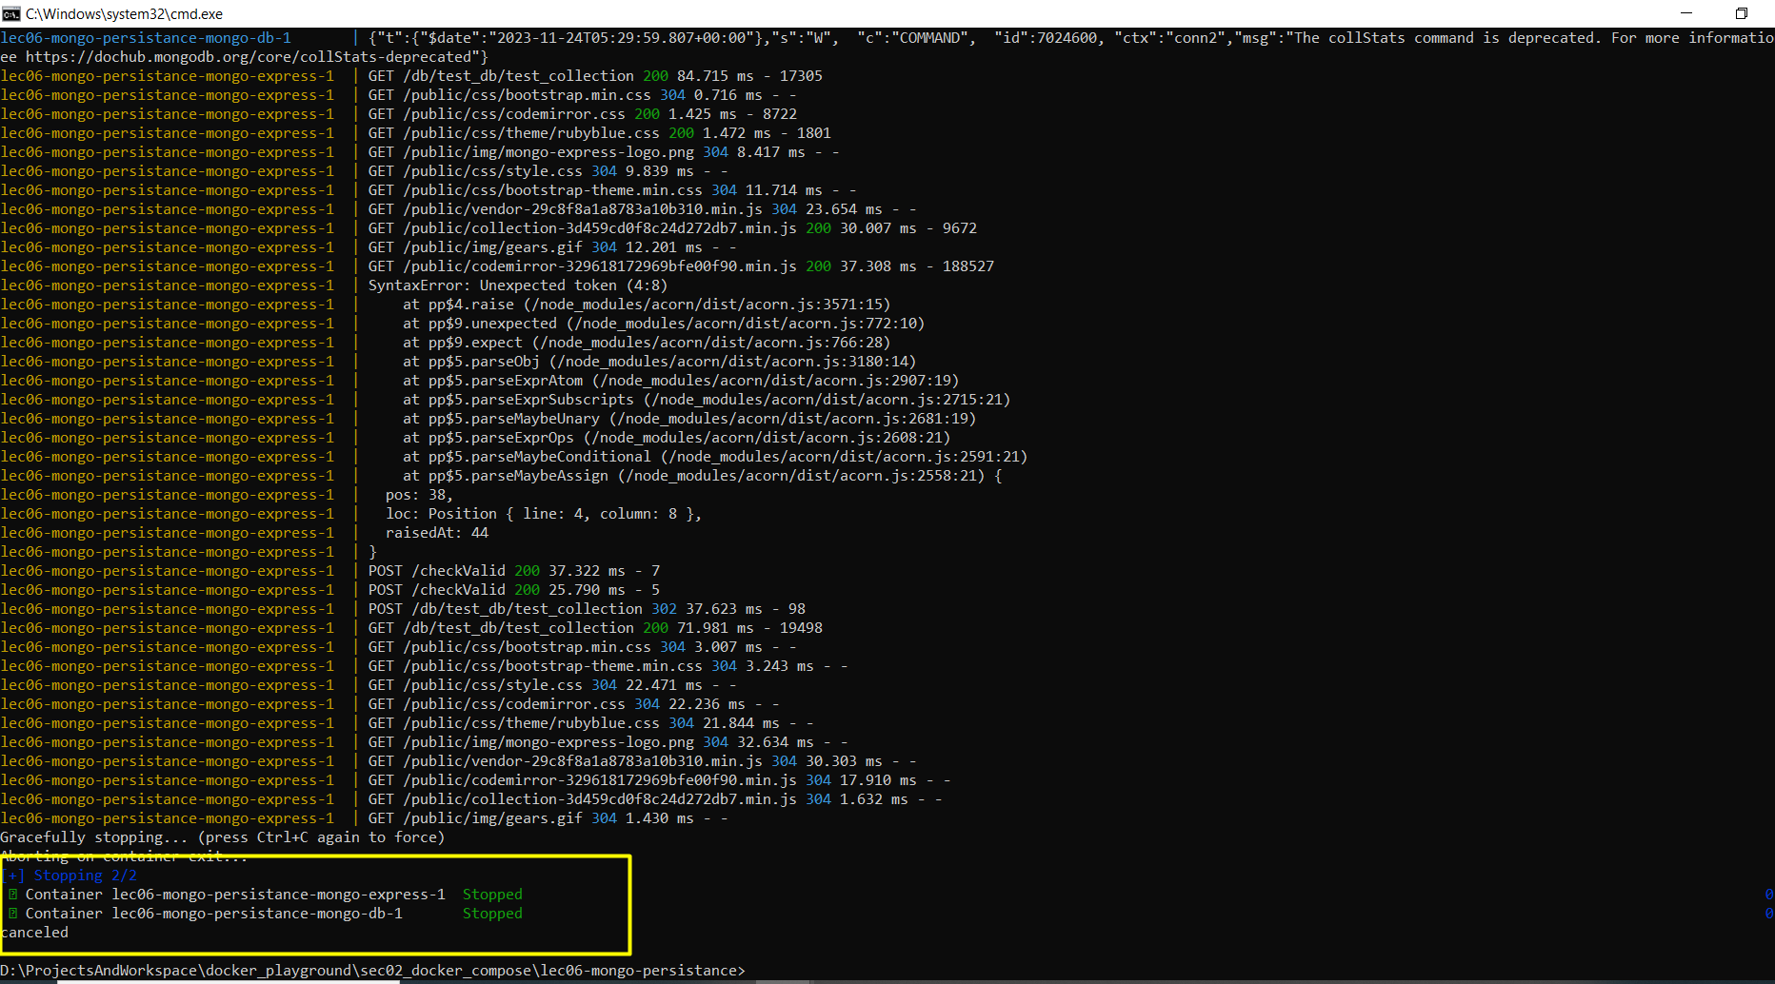

Removed

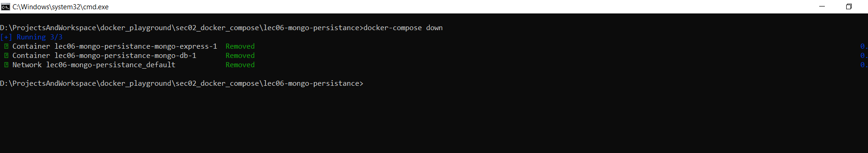

Host machine files

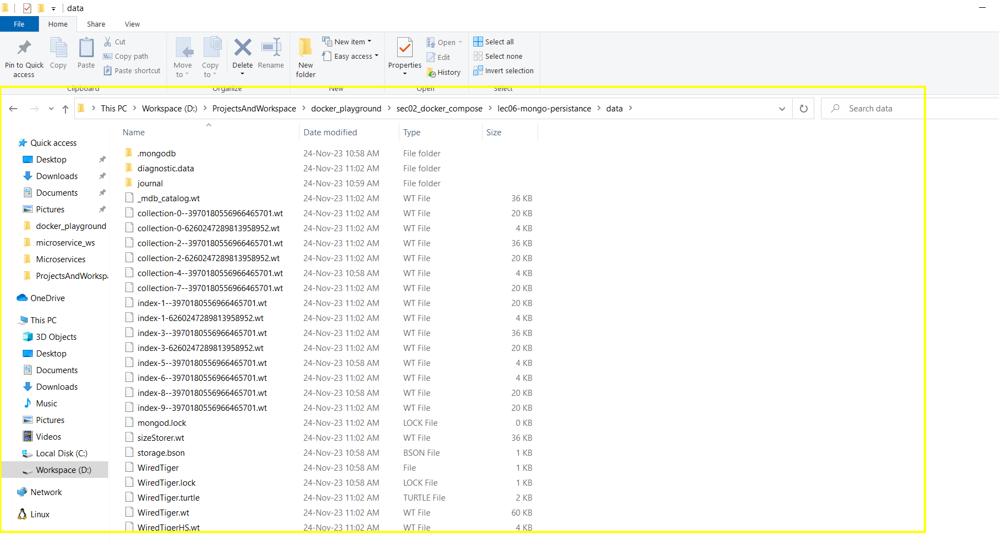

Now again invoke docker-compose up and see previously created document is present or not

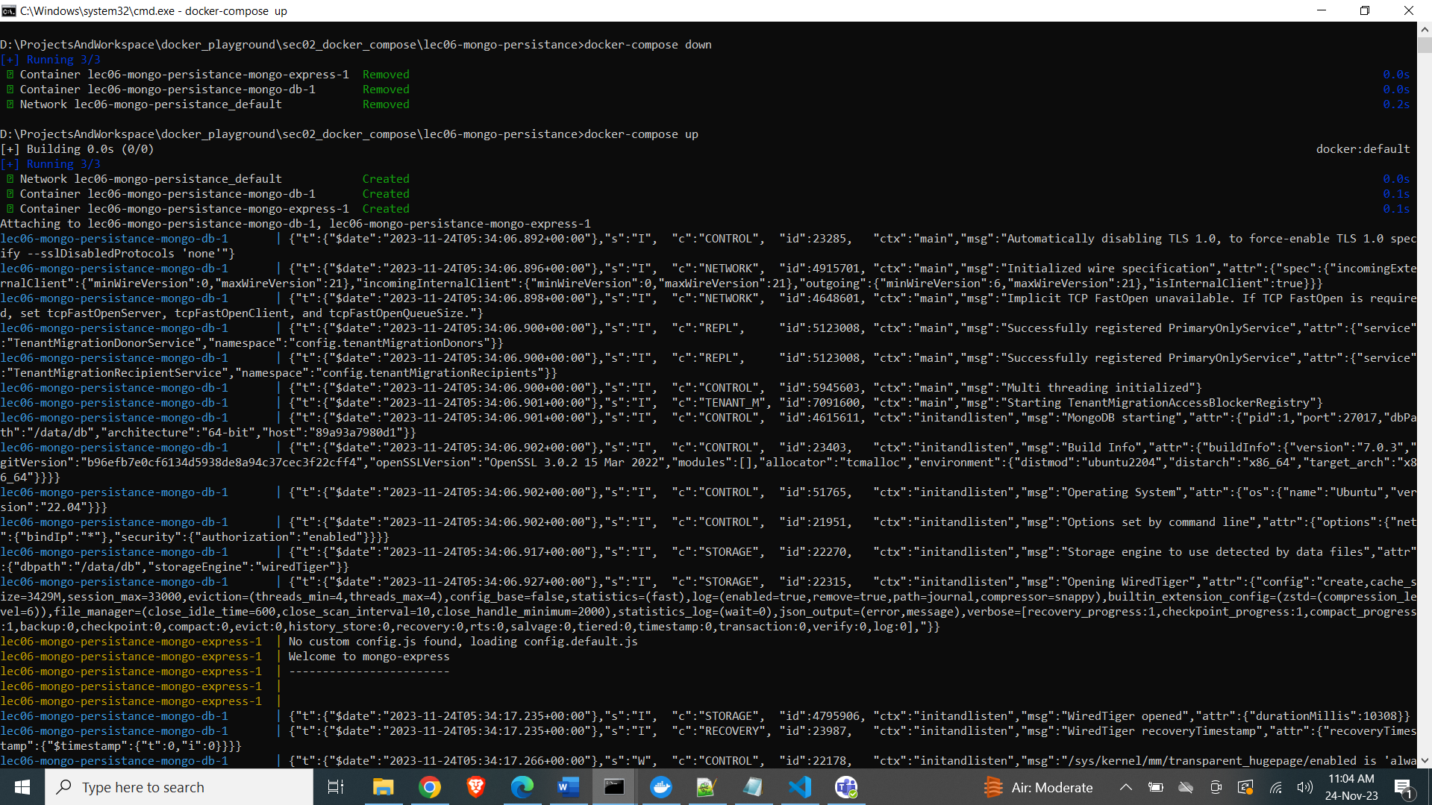

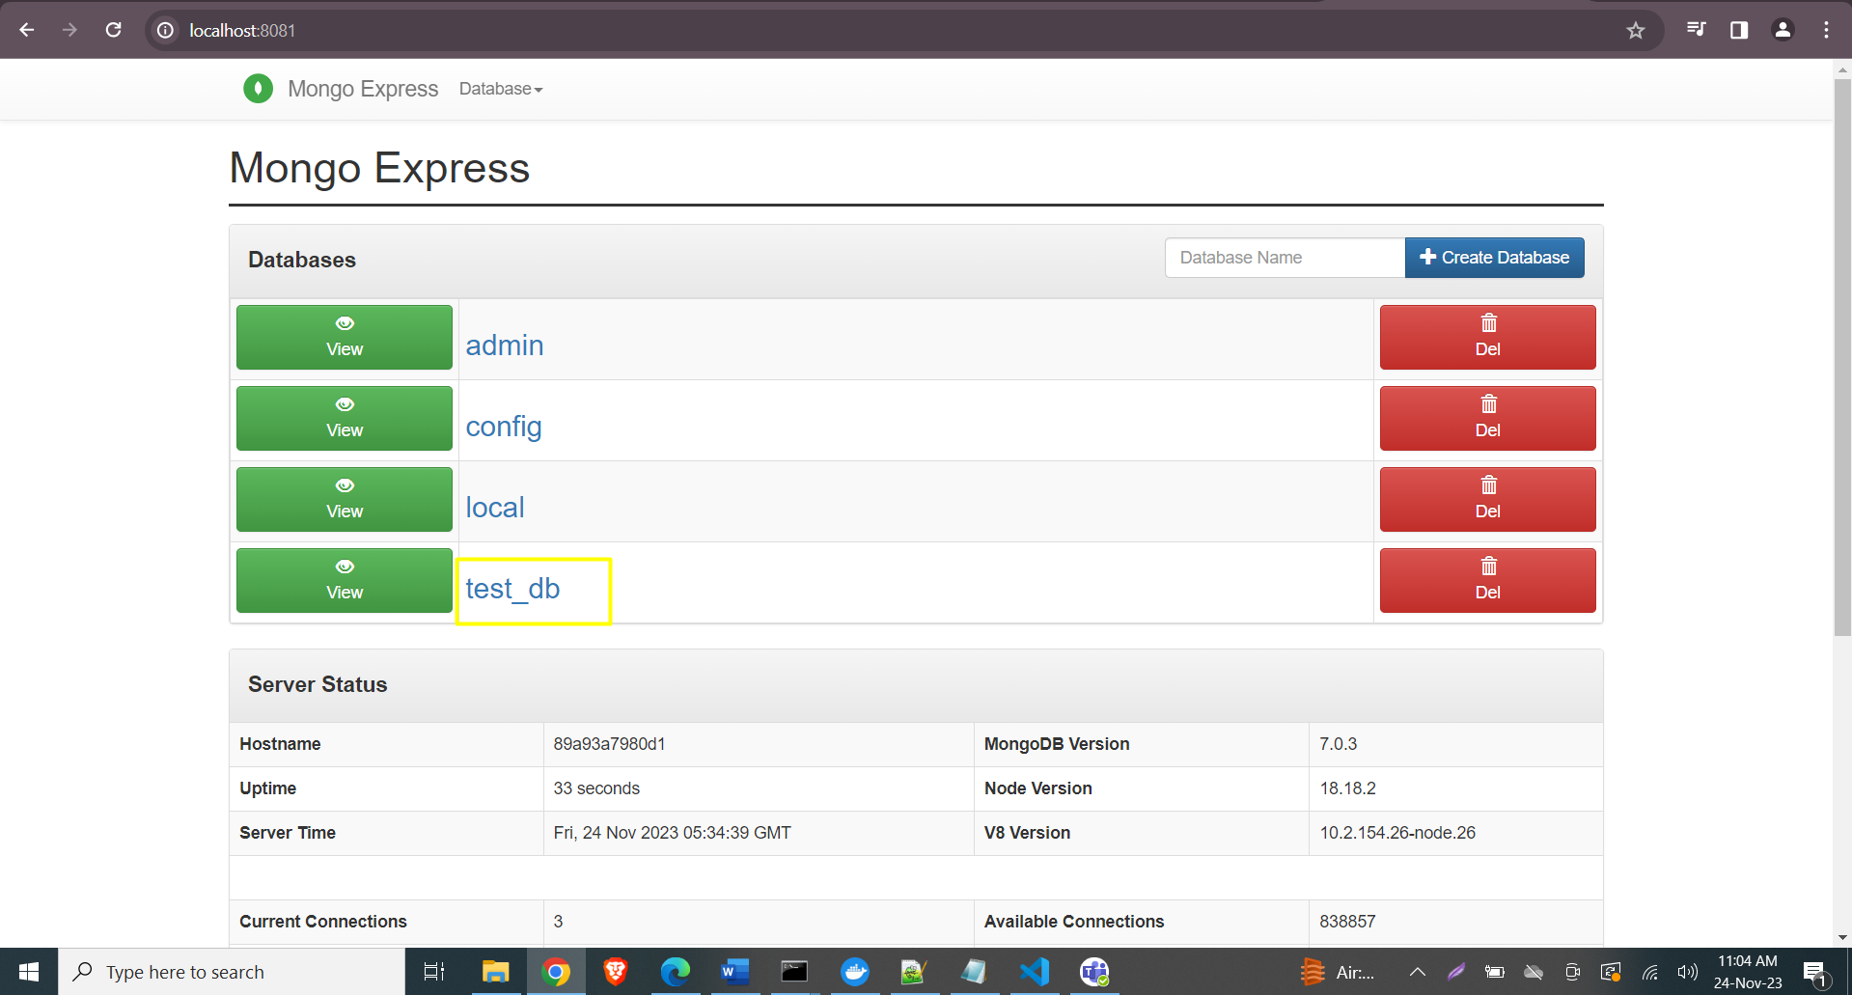

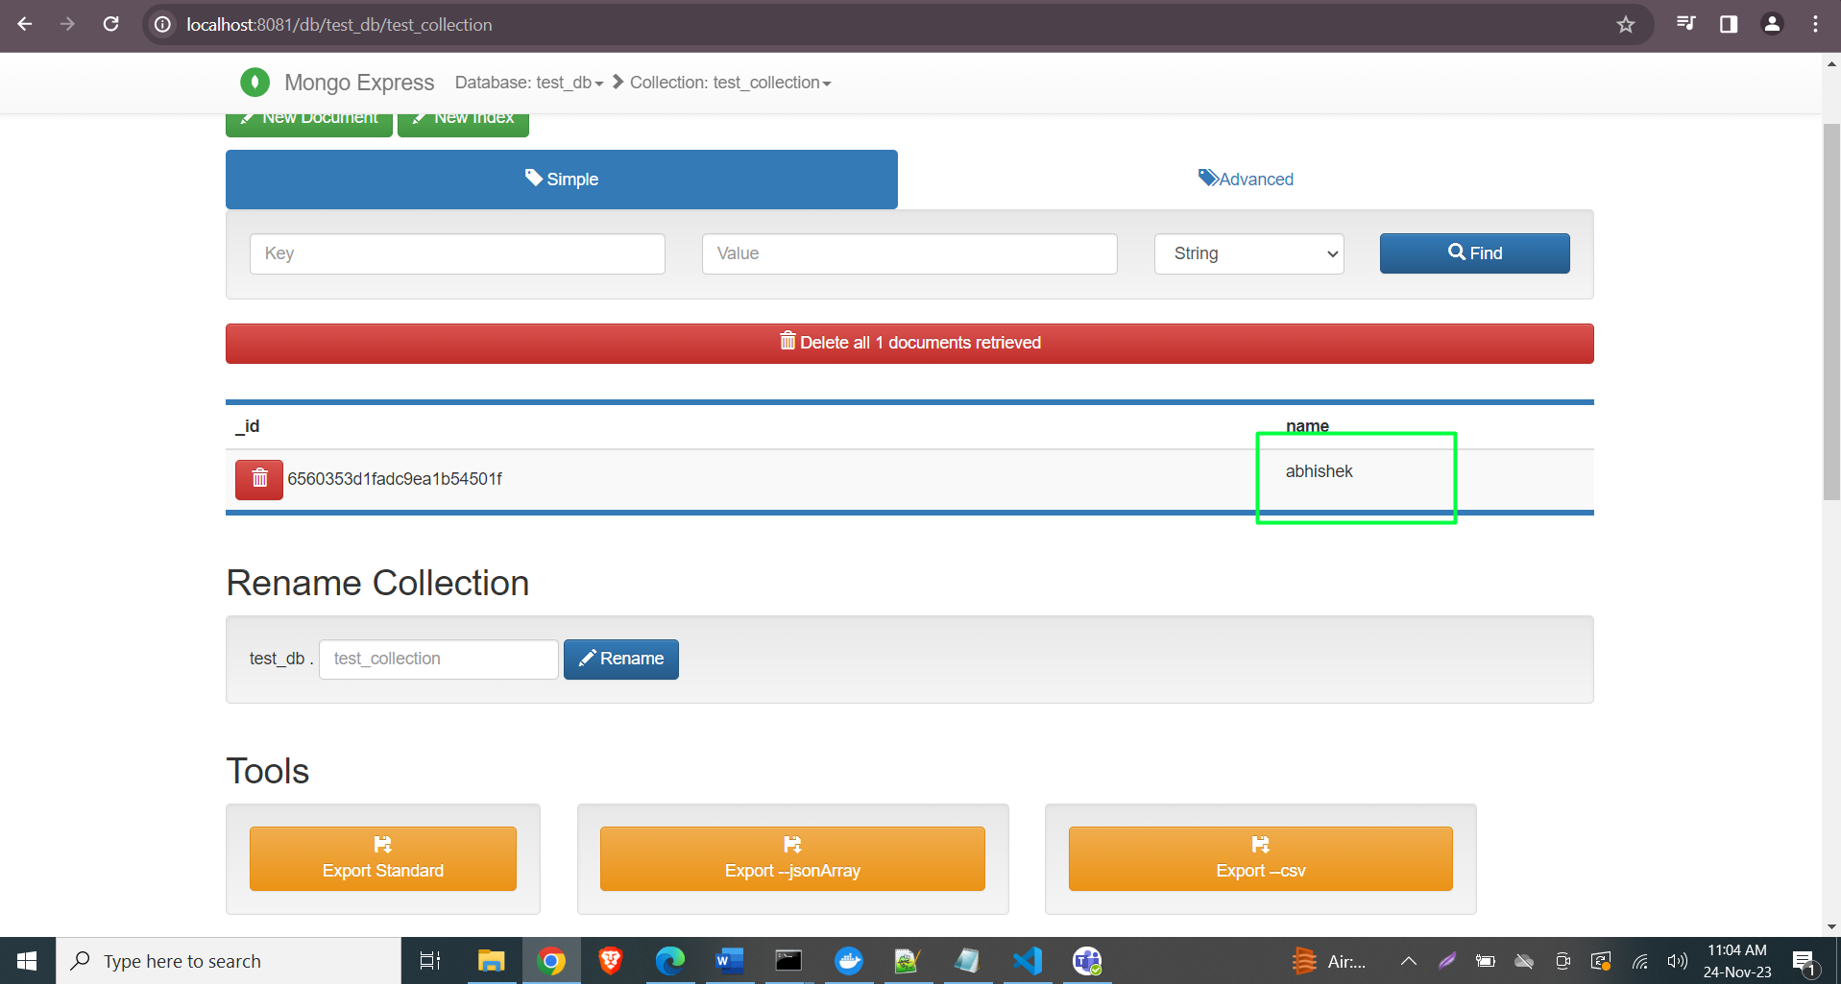

Docker-mongo with spring boot:

Step 1: create spring boot project with below decencies:

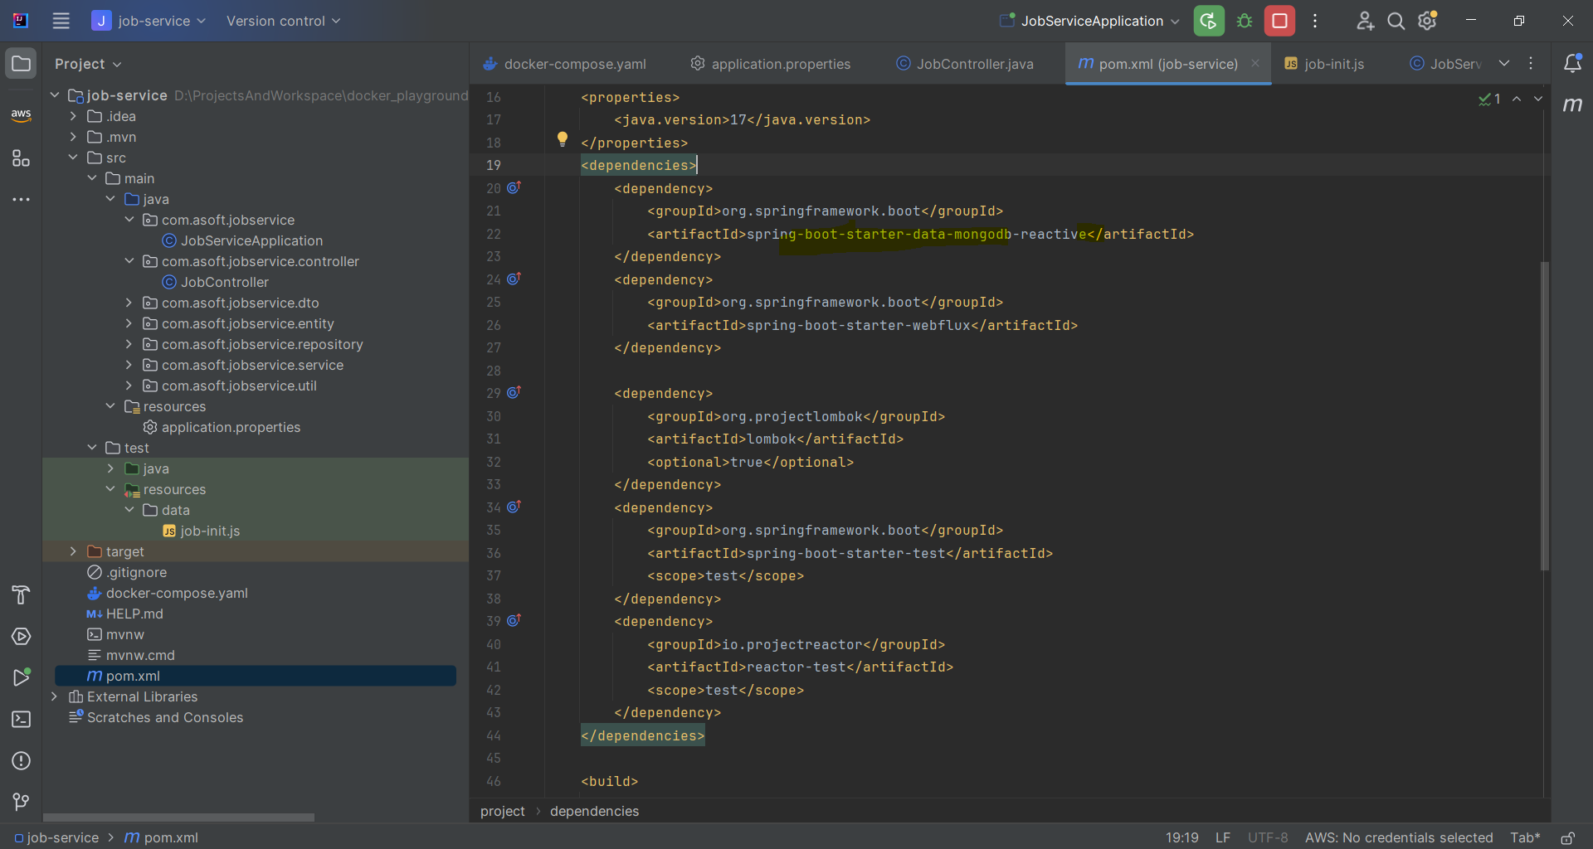

NOTE: This is spring react project, basically you can add mongo db starter instead mongodb-reactive.

Step 2: add docker compose file:

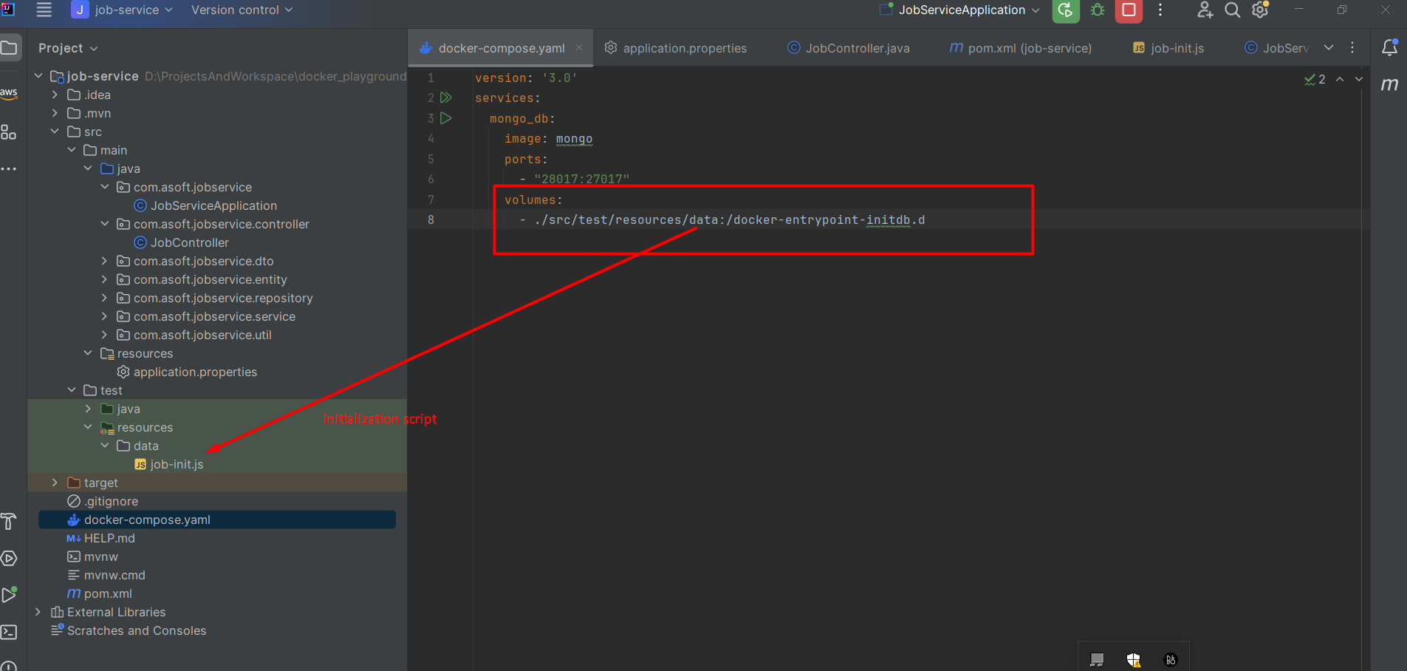

Step 3:

DB url configuration in application.properties

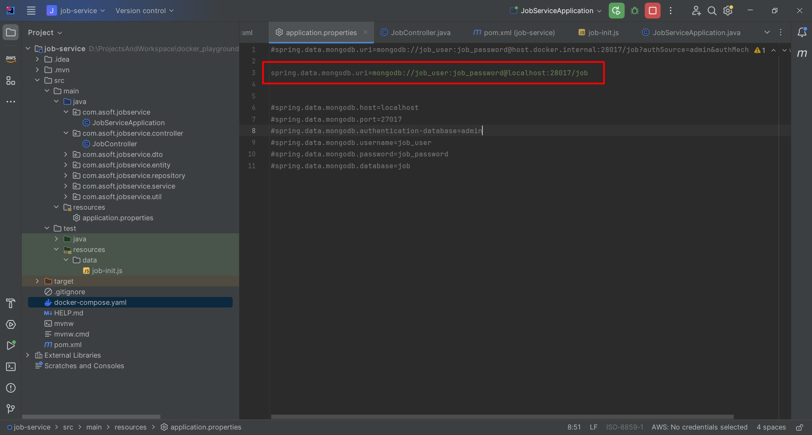

NOTE: DB user: job_user, DB password: job_password. DB username and password has been created from job-init.js

Step 4: invoke docker-compose up command

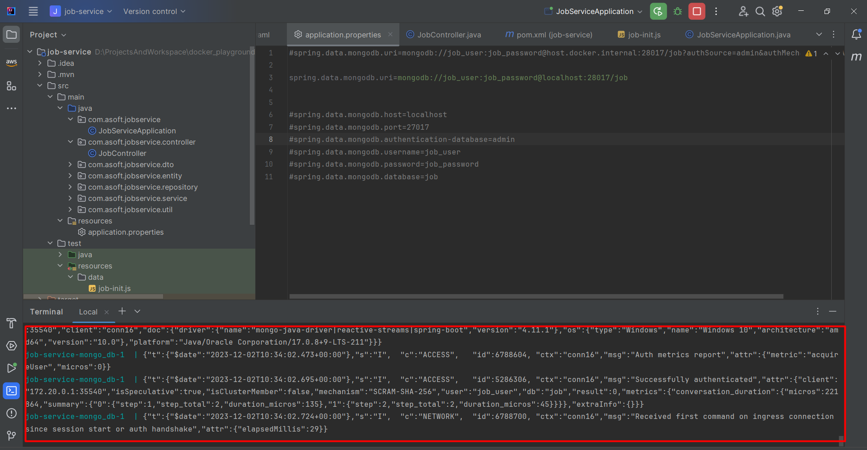

Step 5: start the application and access the sample rest call.

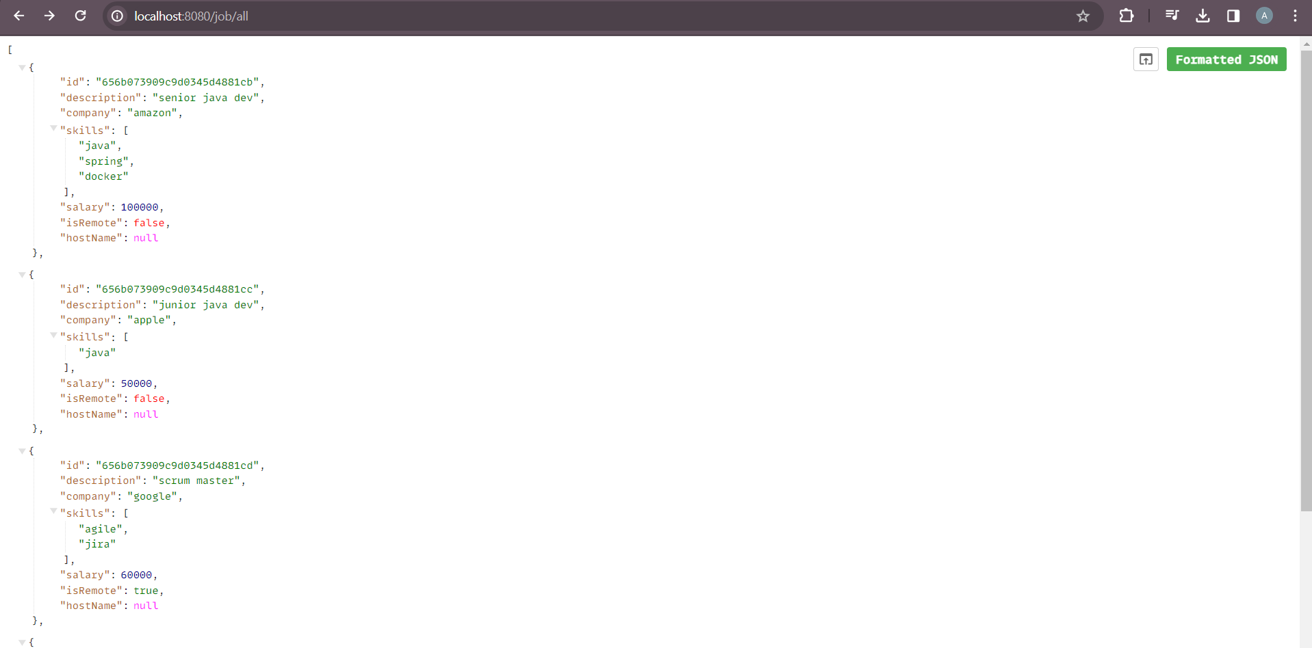

NOTE that job-init.js used to re-load the data.

# Now time has come to dockerized our spring boot application:

Step 1: Build application – I am using maven so invoking “mvn clean package”

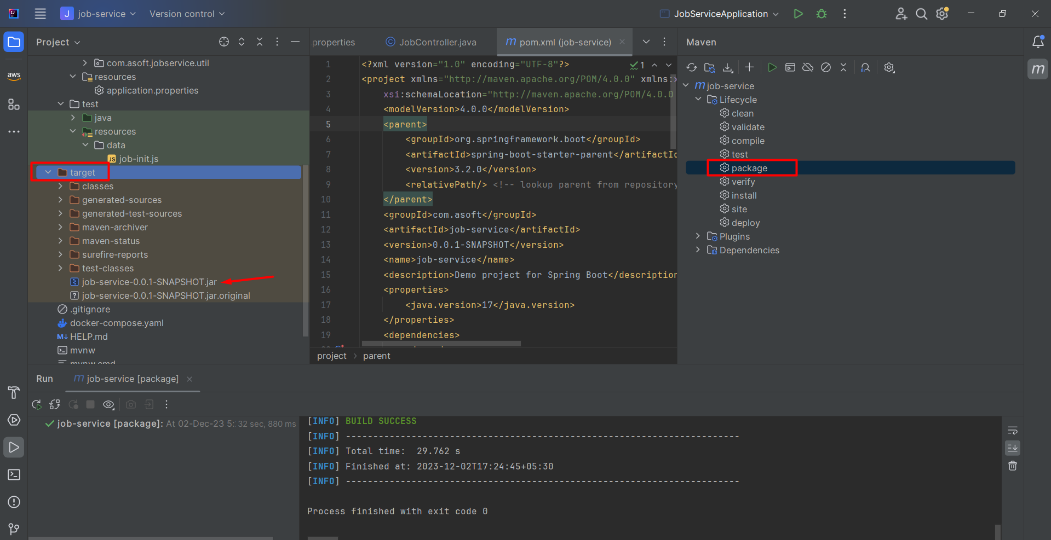

Step 2: write docker file for application that will help you to create docker image of boot application.

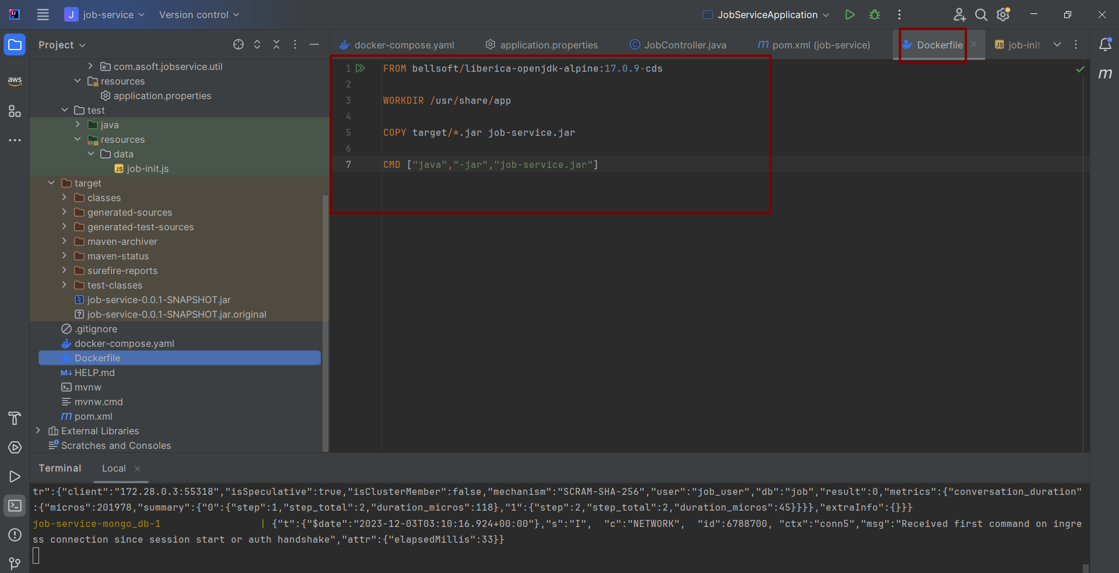

Step 2.1: Build the docker image using “docker build -t job-service . “ command

Step 3: Write a docker-compose.yaml file.

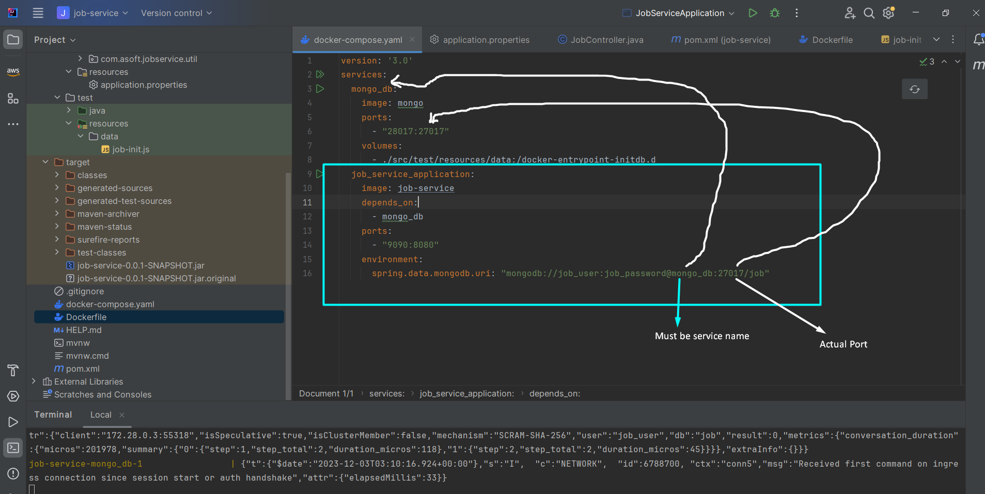

NOTE: You don’t need **“restart: always”** in job_service_application tag, because spring boot is smart enough to make connection with db.

Step 4: Invoke docker-compose up command and see the logs

NOTE: I just copy whole logs into notepad++ filter out spring boot application logs:

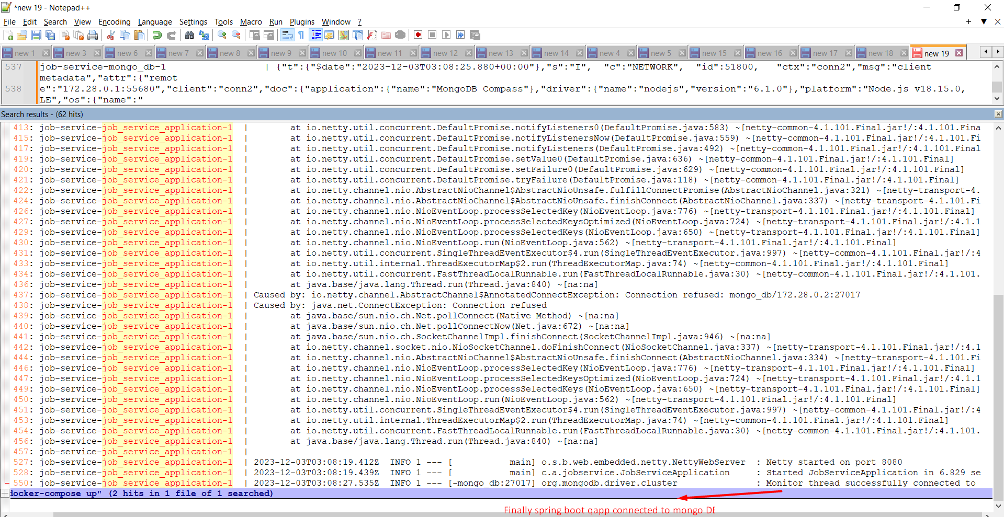

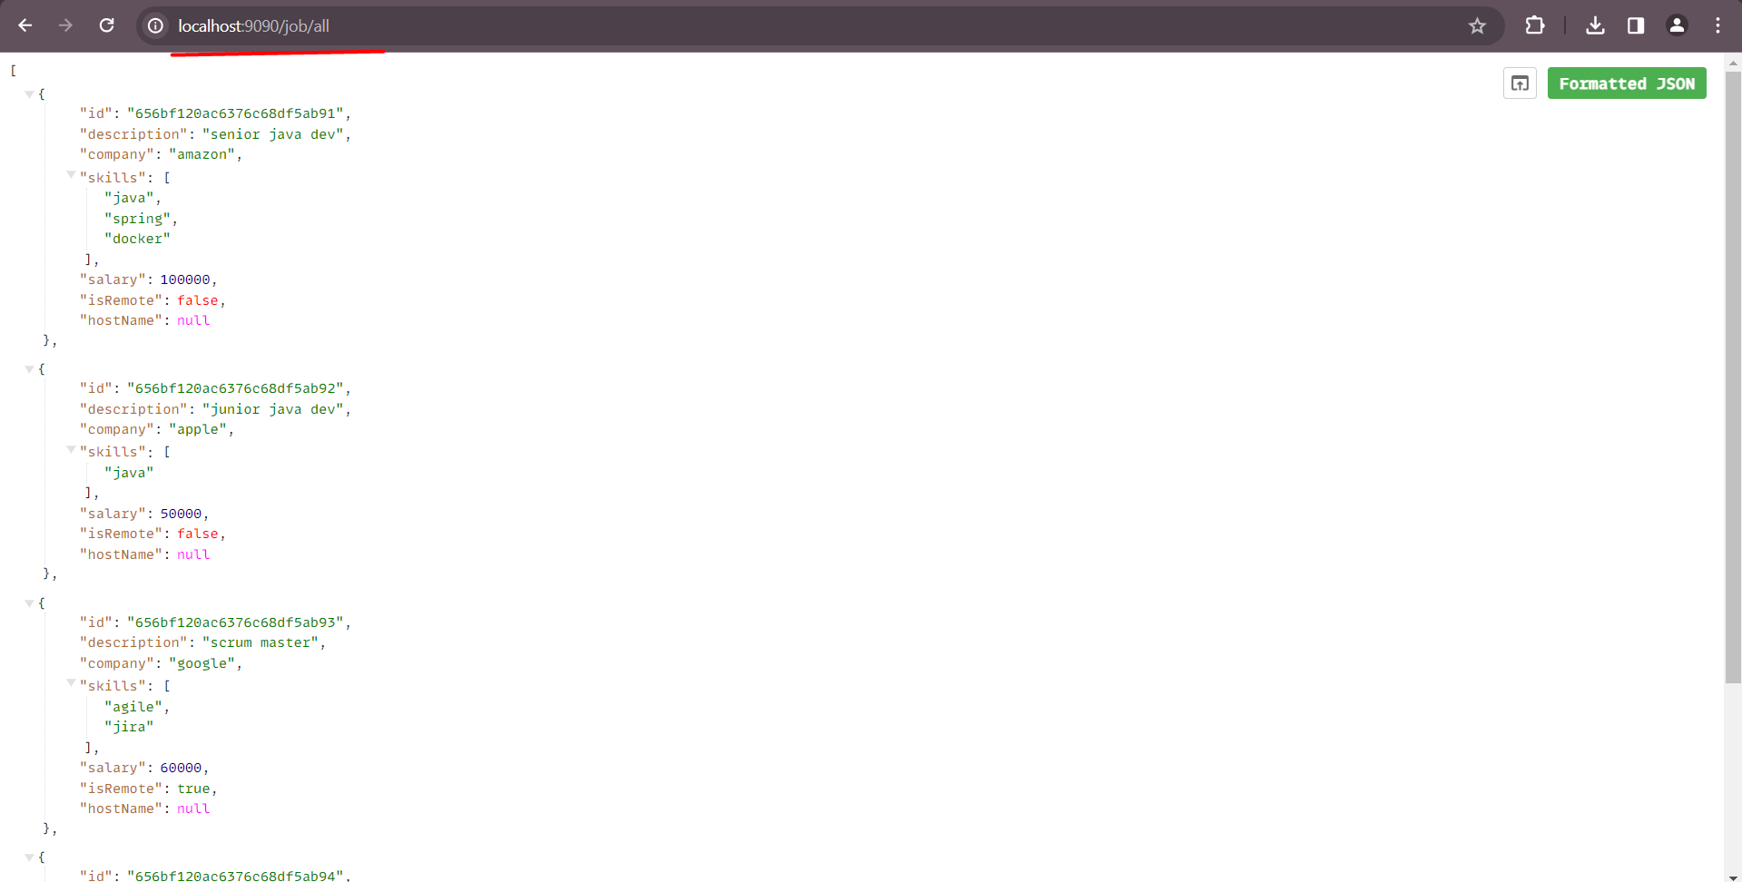

Can we build image from docker compose? Because before invoking “docker-compose up” command we need to invoke “docker build -t job-service .” command to build the our application docker image.

* We can do this in below way.

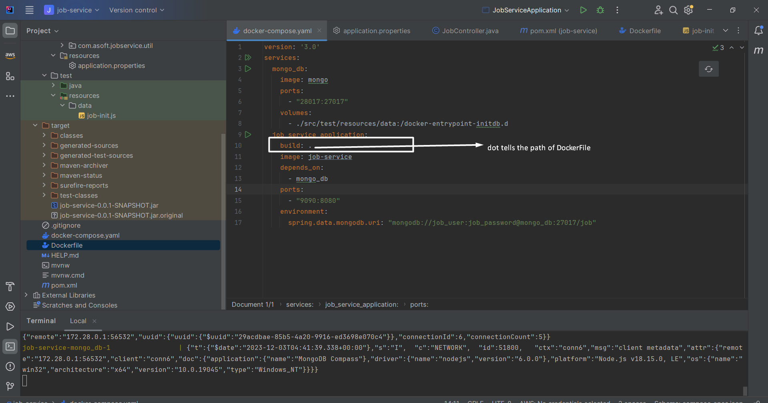

After “docker-compose up”

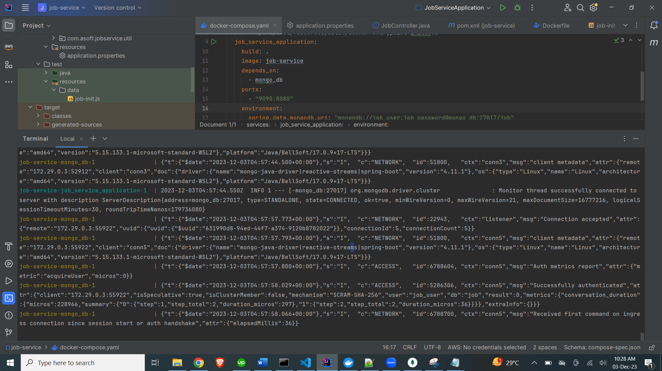

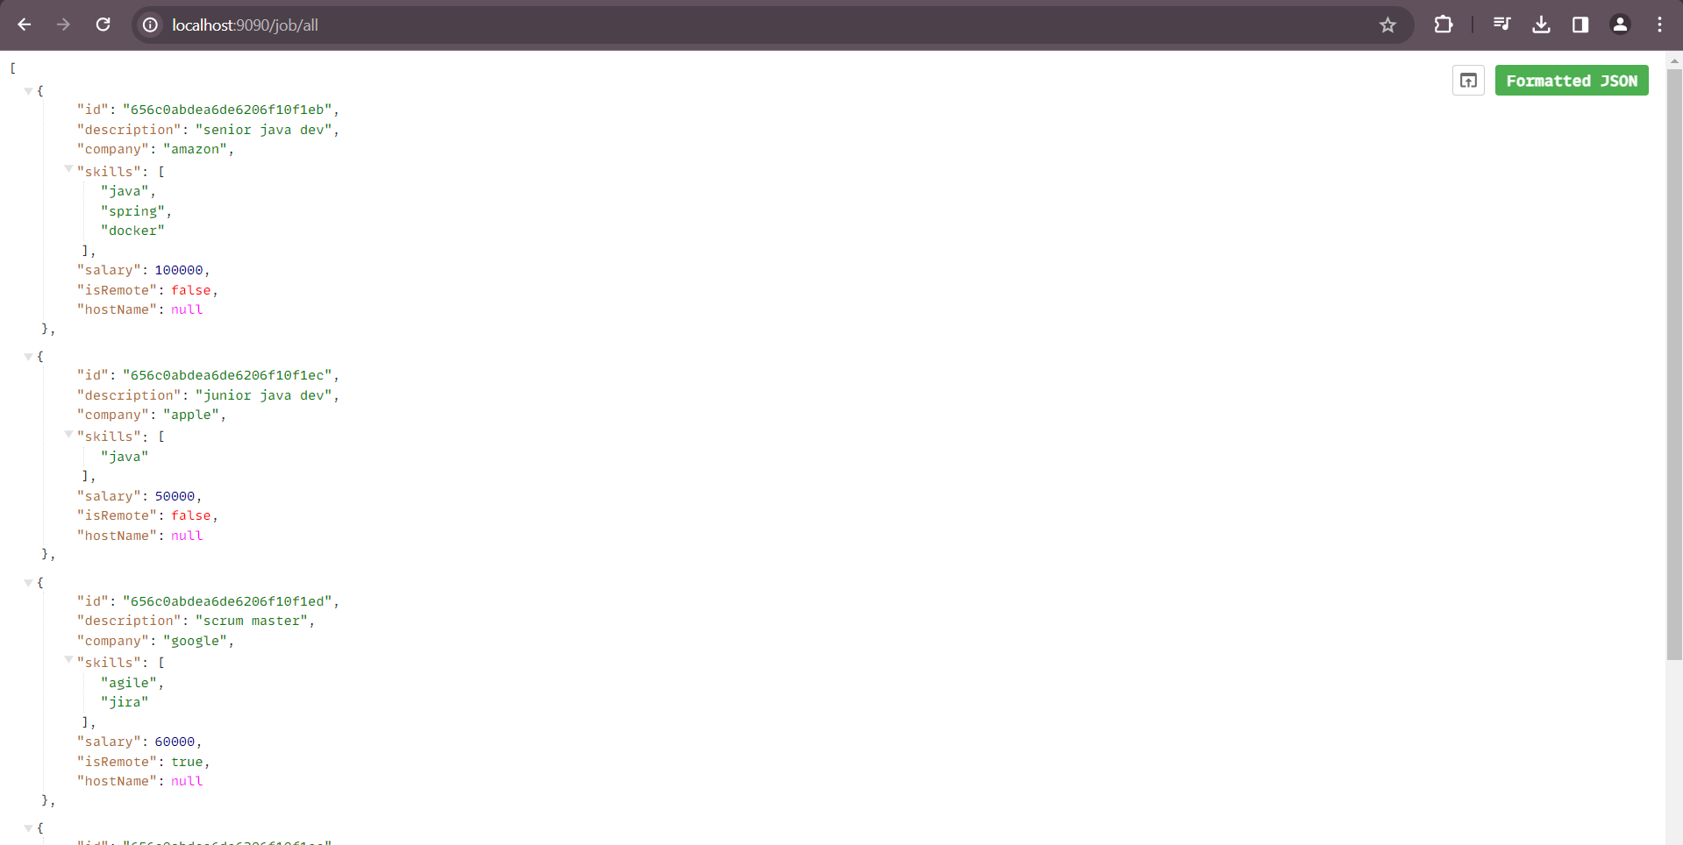

# Docker compose profile

Requirement: As you can see your docker-compose file have multiple services like mongo-db, job-service etc. Let say you are still in the development phase and you want only mongo db service to up o your local but not job-service? Then how do you achieve this ?

* One way is using “docker-compose up {service-name}” you can achieve this.

Intelije option

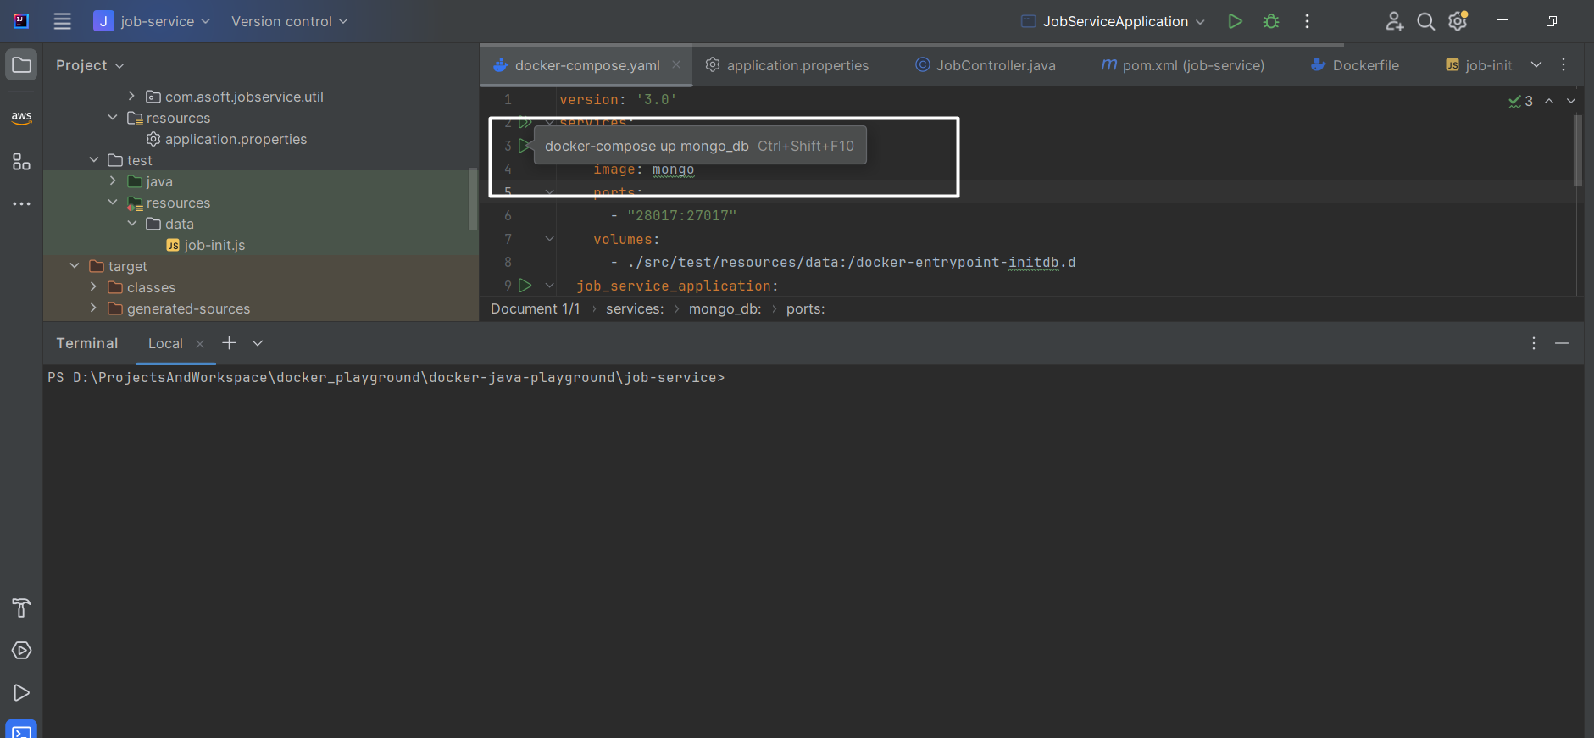

Using profile:

As you can see in below docker-compose file, you can set the profile to particular service and when you invoke docker compose command with that profile name then that service is get up.

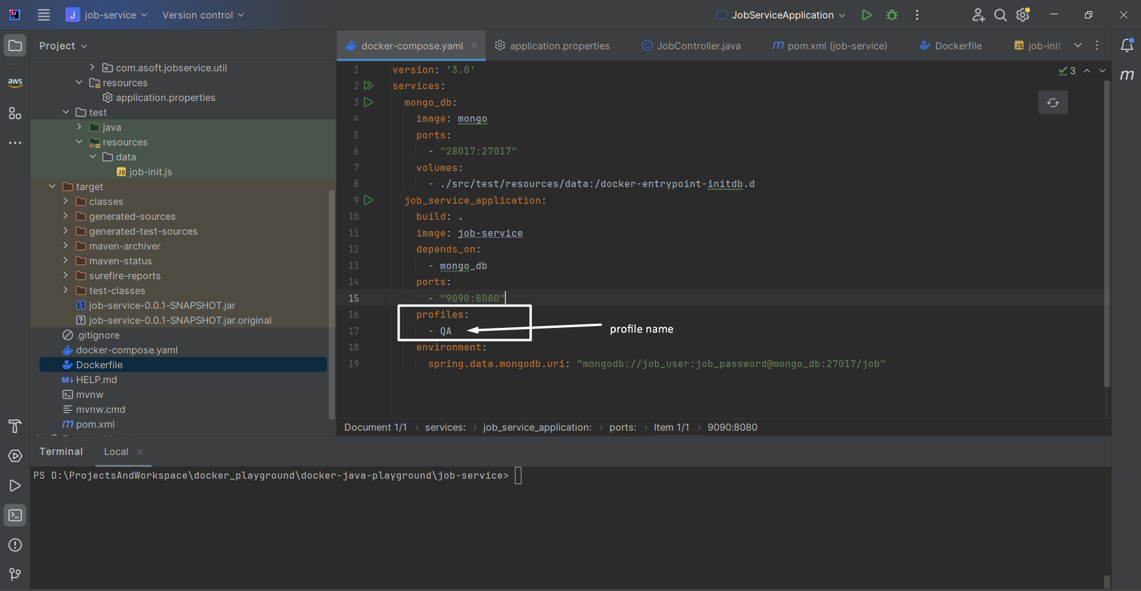

Running “docker-compose up” > It is expected that only mongo-db service will up, let’s see

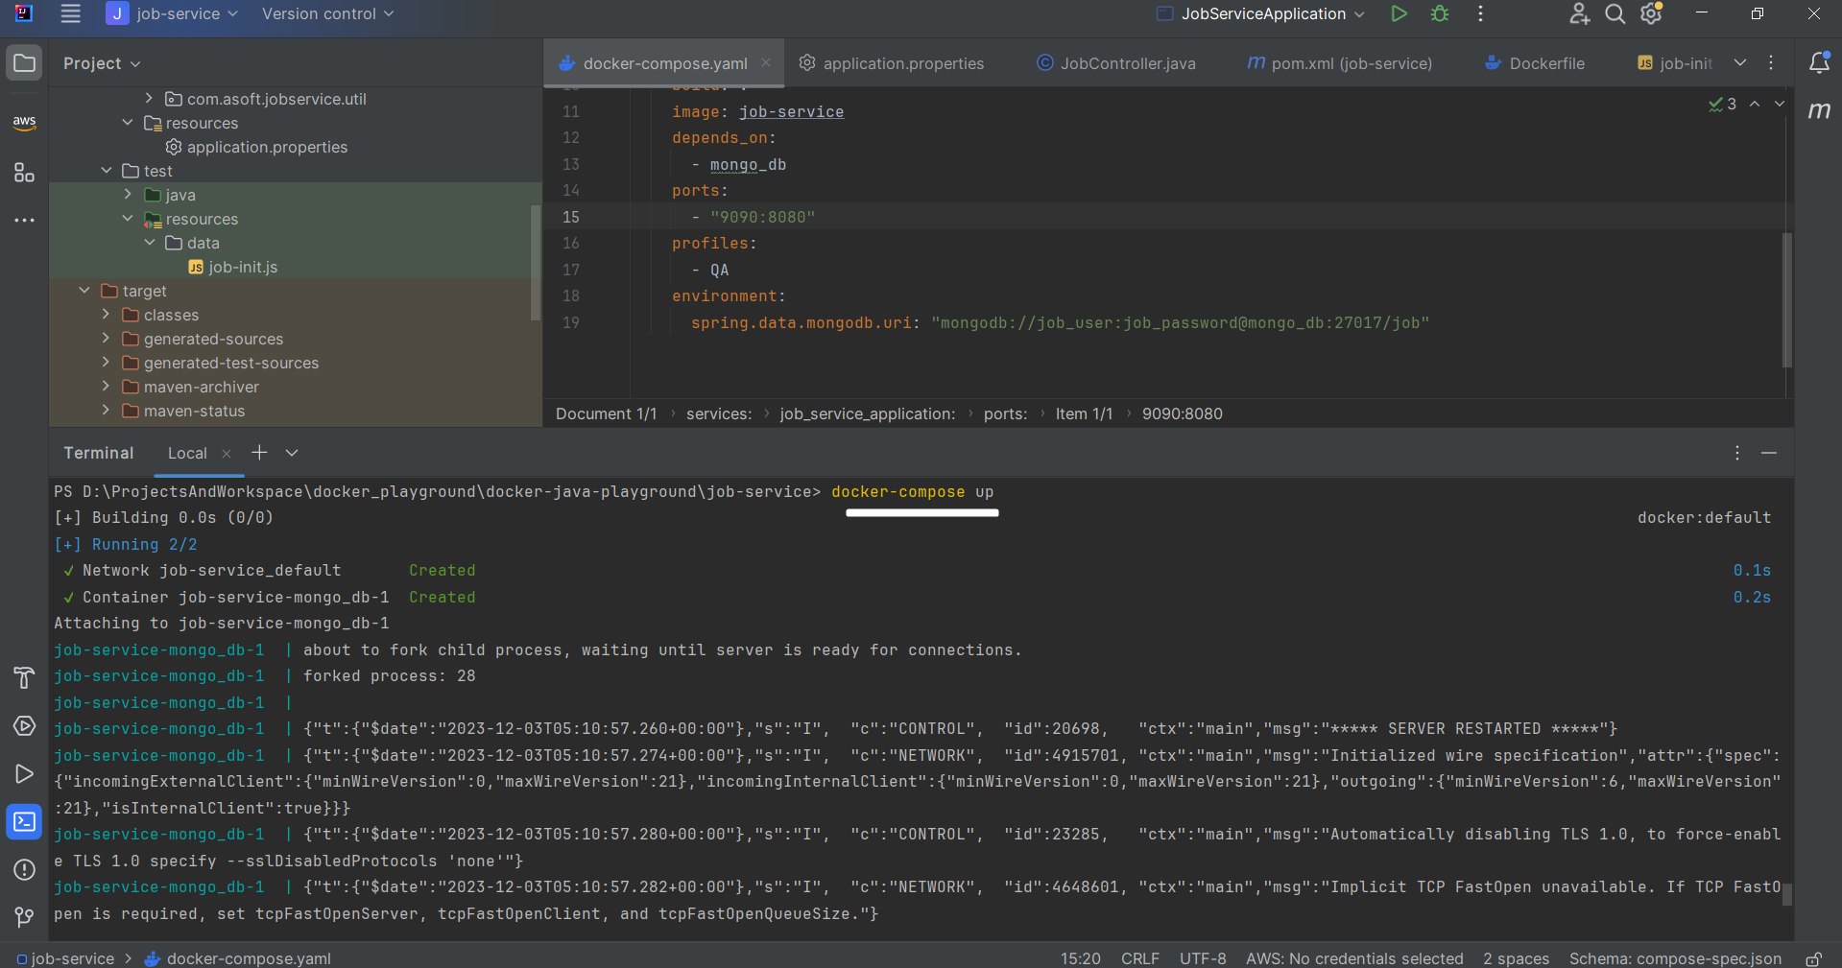

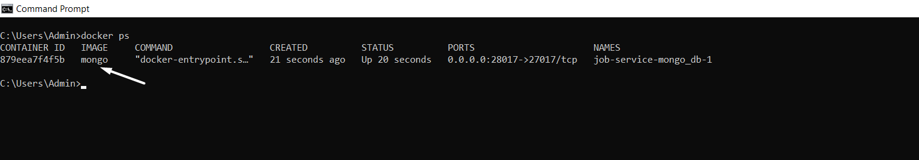

Now using “docker-compose - -profile=QA up”

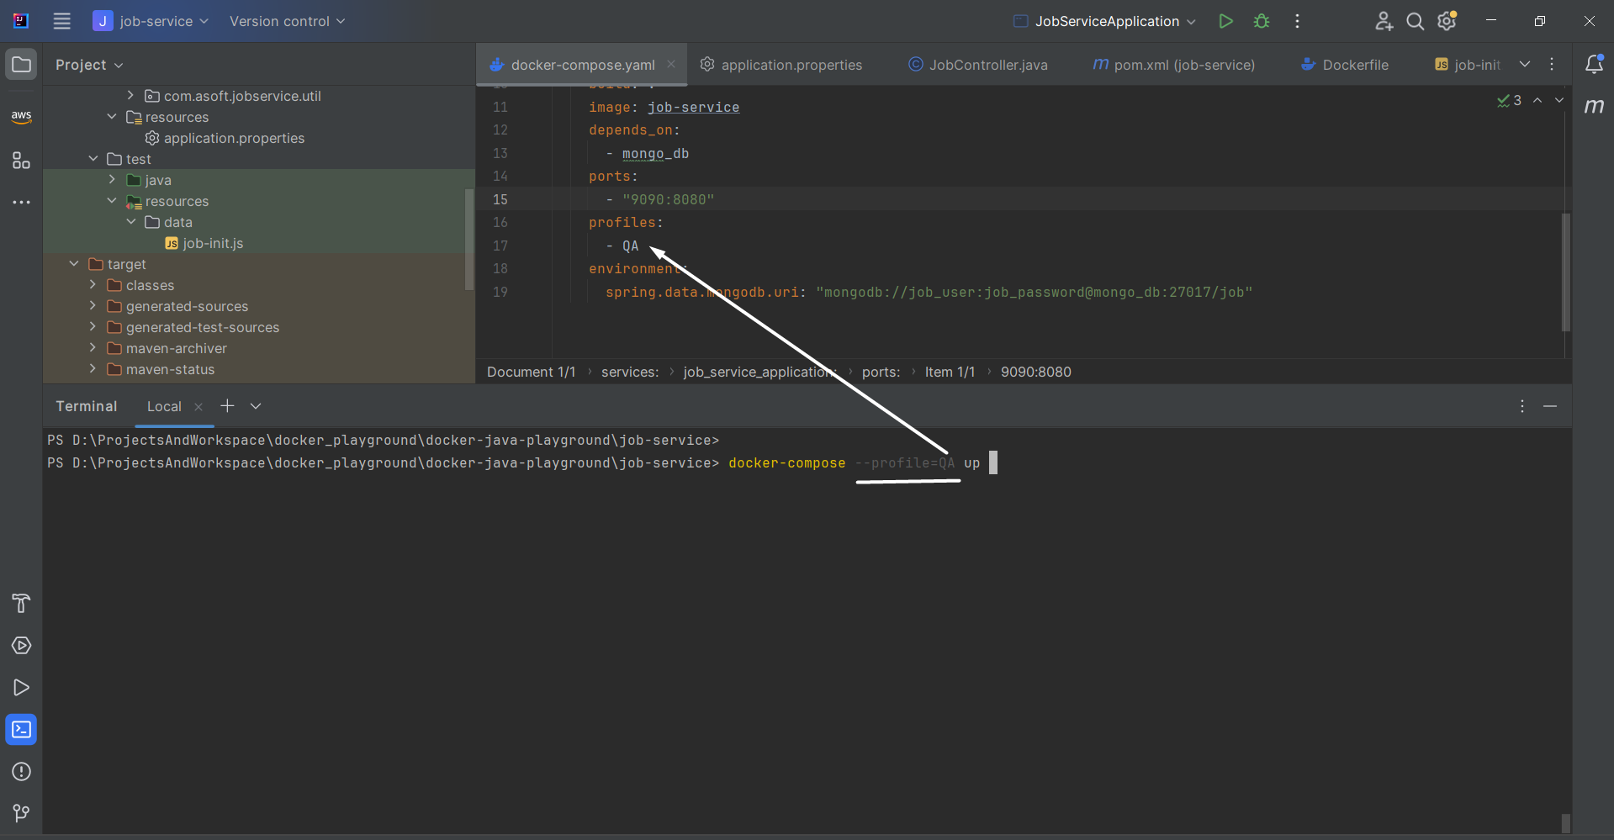

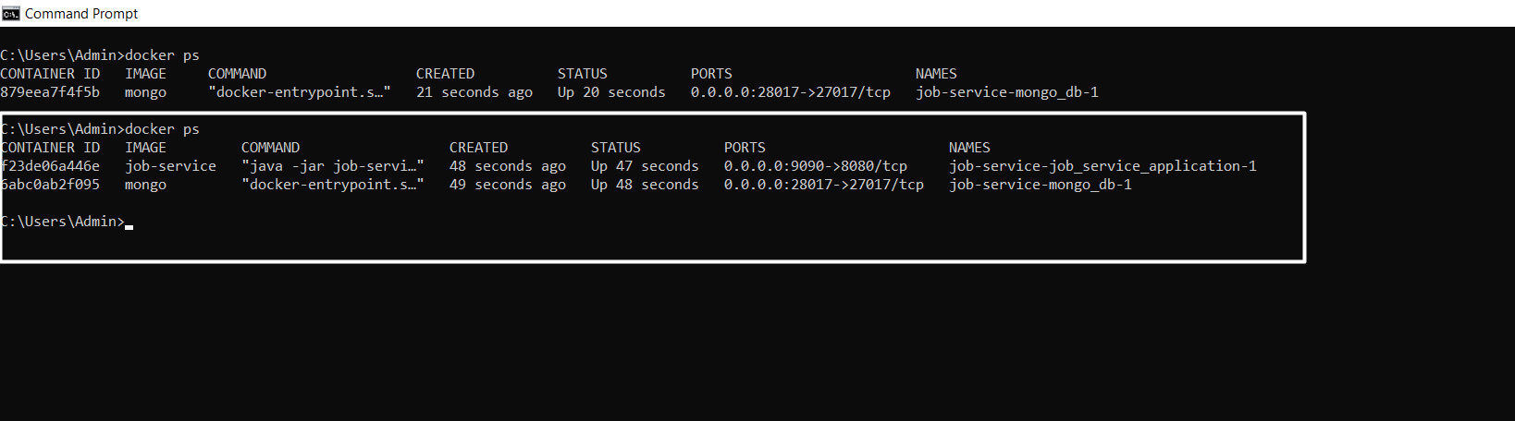

# Multi Stage Dockerfile

What if ,if you want to build your project from dockerfile.

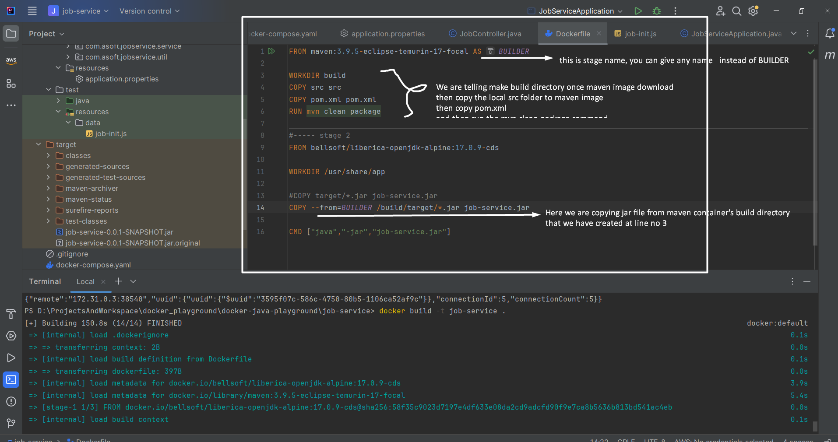

After docker build -t job-service .

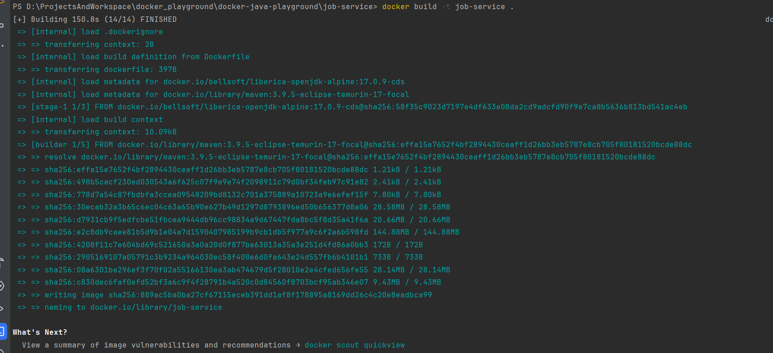

docker image using maven command

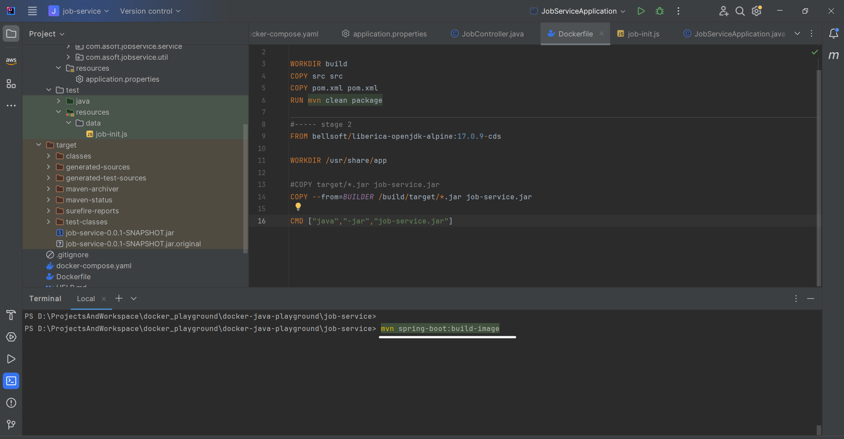

# Test container

Add testcontainer dependency to project

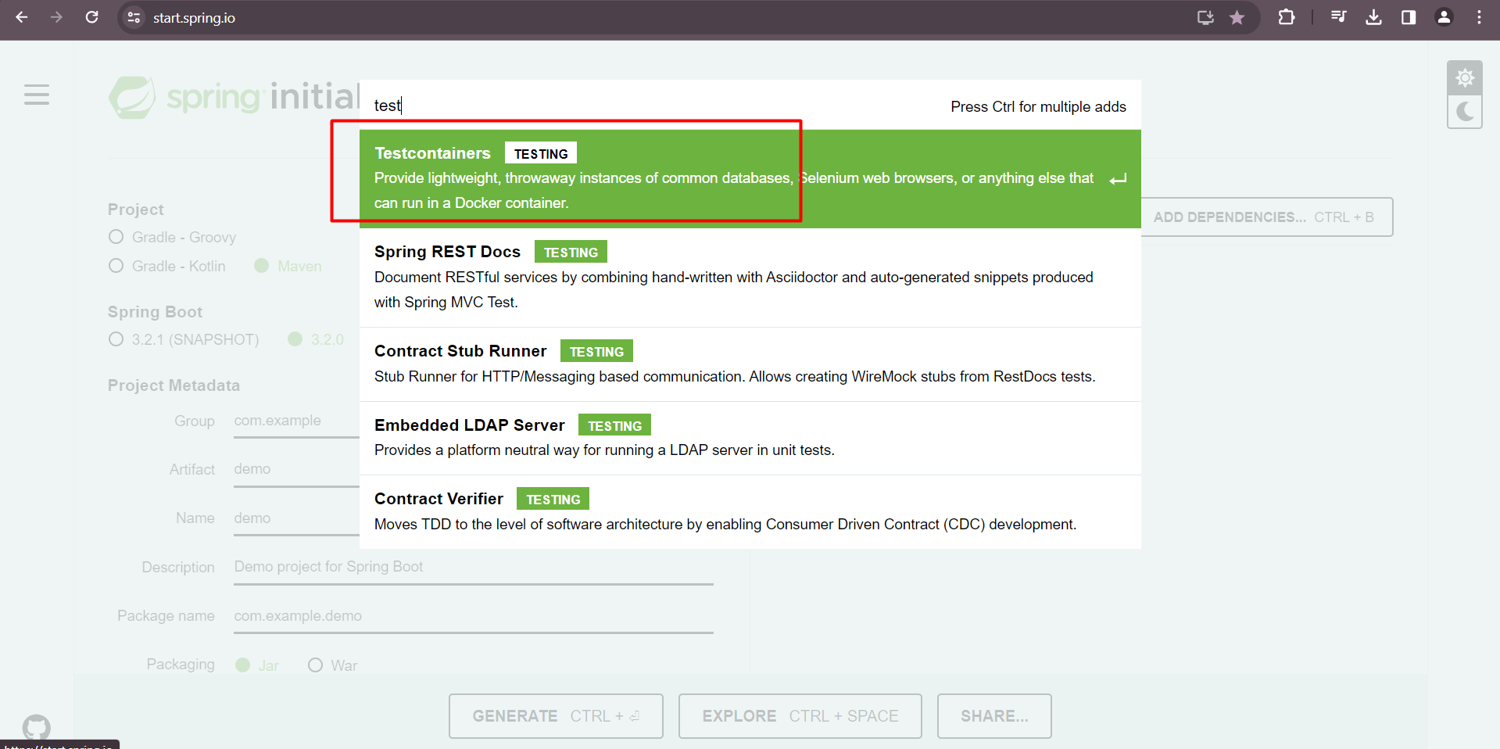

Copy below dependencies

